**Dolphin Bakery - Online Bakery Ordering System**

**1. PURPOSE OF THIS DOCUMENT**

The aim of this document is to describe the online cakeshop website Dolphin Bakery. This document provides information about the technical information and the implementation of the website.

**1.1 INTRODUCTION**

Dolphin Bakery is an e-commerce store website aimed to facilitate the sale and distribution of freshly baked cakes across India. Dolphin Bakery website provides easy access to choose and buy from a large variety of cakes and makes it easy to get the cakes delivered at a desired location.

**1.2 SCOPE**

The aim of the project is to develop a friendly e-commerce store website. The e-commerce website should target both desktop devices and mobile devices. The e-commerce website should have a front-end and back-end interface. The e-commerce website should target people who likes to buy cakes on both a regular basis or for special occasions.

**1.3 AIMS AND OBJECTIVES**

The main aim and objective of this project is to design and implement a website which consists of these basic features:

- Responsive Front-end interface

- Connection to a database for data storage

- Registering the customers

- Registering the admins

- Display the products on the website

- Enable users to filter products

- Enable the user to choose and buy desired products

**1.4 FUNCTIONAL REQUIREMENTS**

1. The website should consist of a home page.

2. The website should consist of an authentication page.

3. The website should allow the user to sign up to an account.

4. The website should allow the user to sign in to an account.

5. The website should consist of an account details page.

6. The website should allow the user to view his account details.

7. The website should allow the user update his account details.

8. The website should consist of a products page.

9. The website should allow the user to view the products.

10. The website should allow the user to add products to his/her cart.

11. The website should consist of an about page.

12. The website should consist of an admin panel.

13. The website should consist of a navigation bar.

**1.5 NON-FUNCTIONAL REQUIREMENTS**

1. The website should be implemented using HTML, CSS and JavaScript as the front-end language.

2. The website should be implemented using PHP and AJAX as the back-end language.

3. The website should be using MySQL database as the Real-time database.

4. The website should be responsive to most screen sizes.

5. The website should allow only allow one user to sign at a time.

6. The website should save a session

7. The website should be showing the navigation bar on every webpage.

**2. IMPLEMENTATION**

This section will provide the details about each page and screen-shots.

**2.2 PC BROWSER SIZE**

The following screen-shots shows the website viewed in a web browser on a screen size larger than 1200 px.

**2.3 SCREENSHOTS**

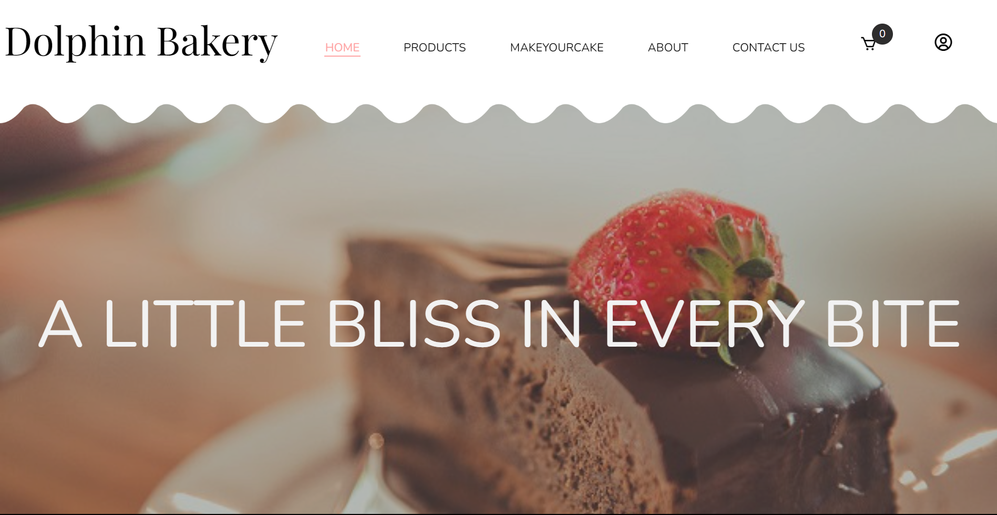

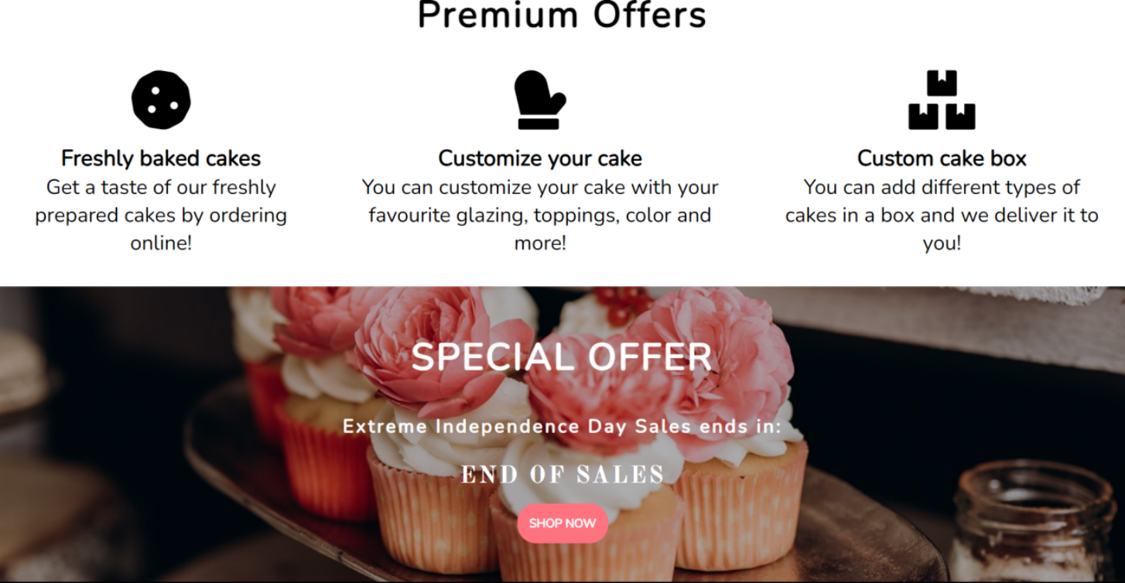

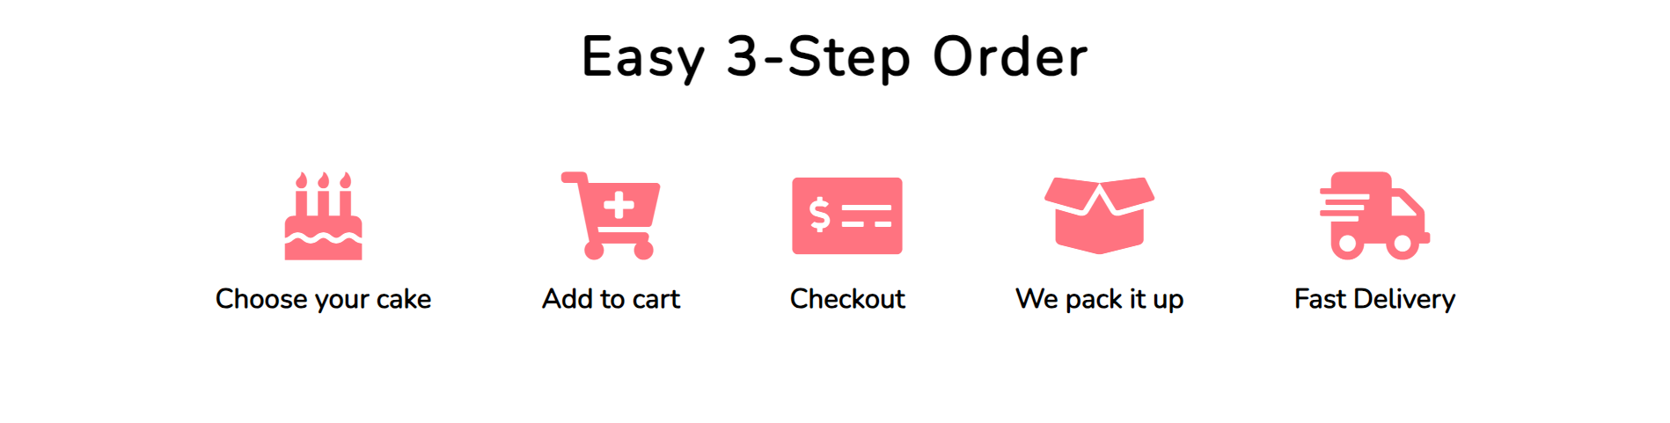

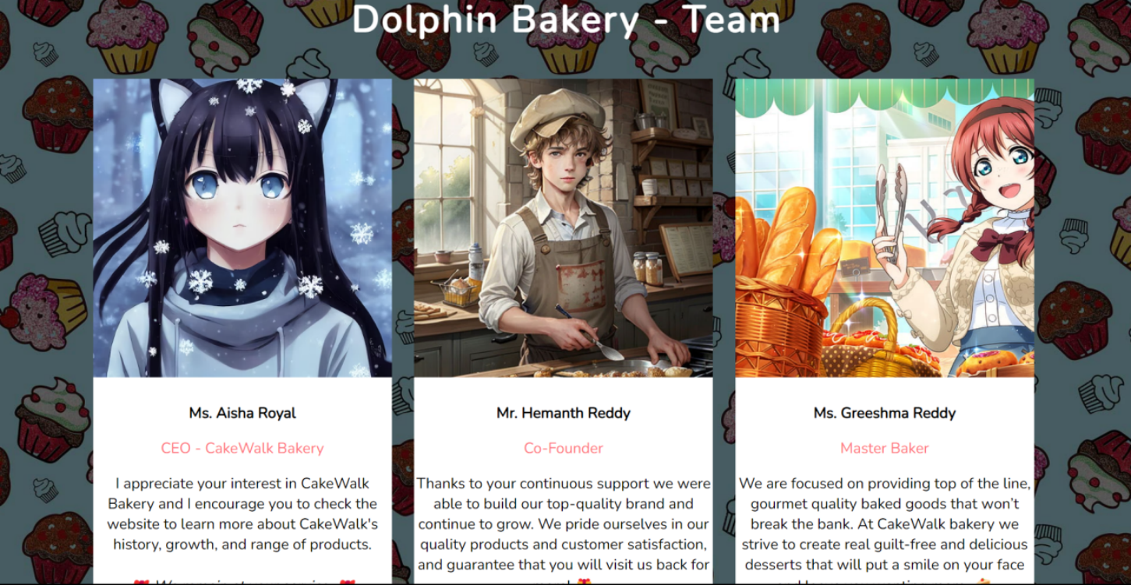

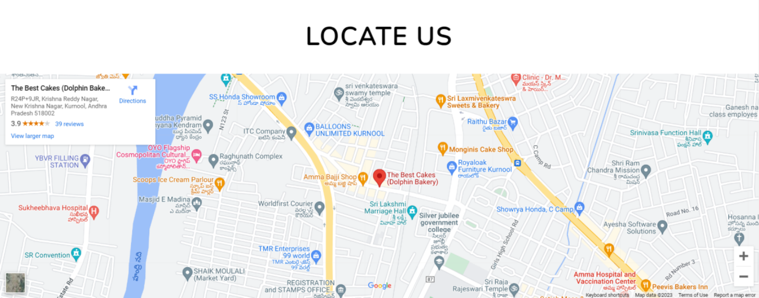

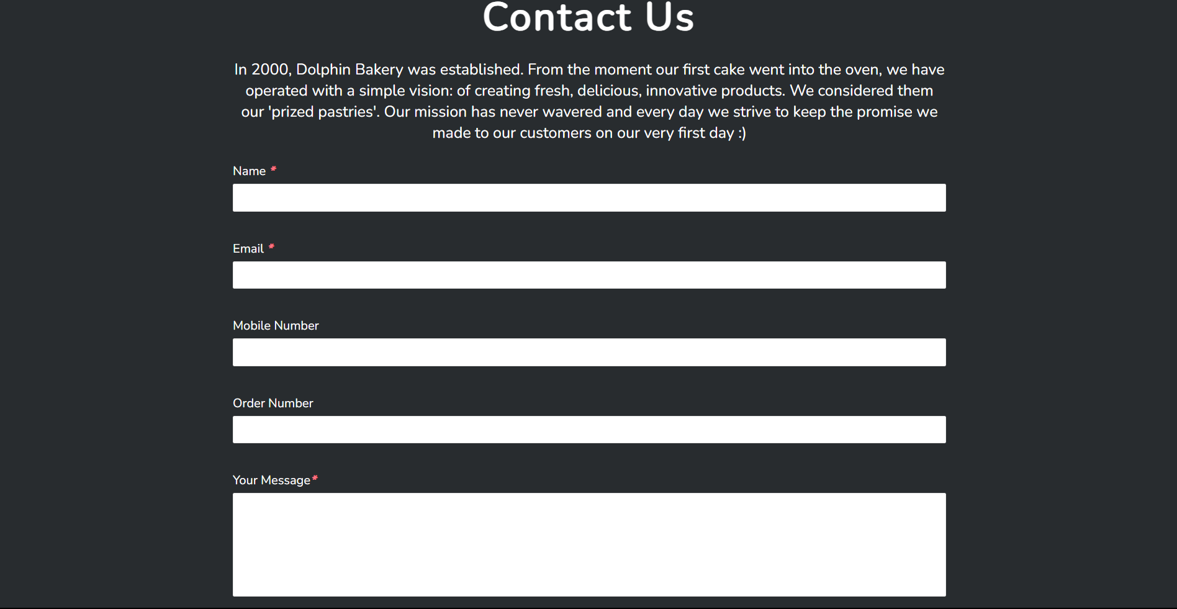

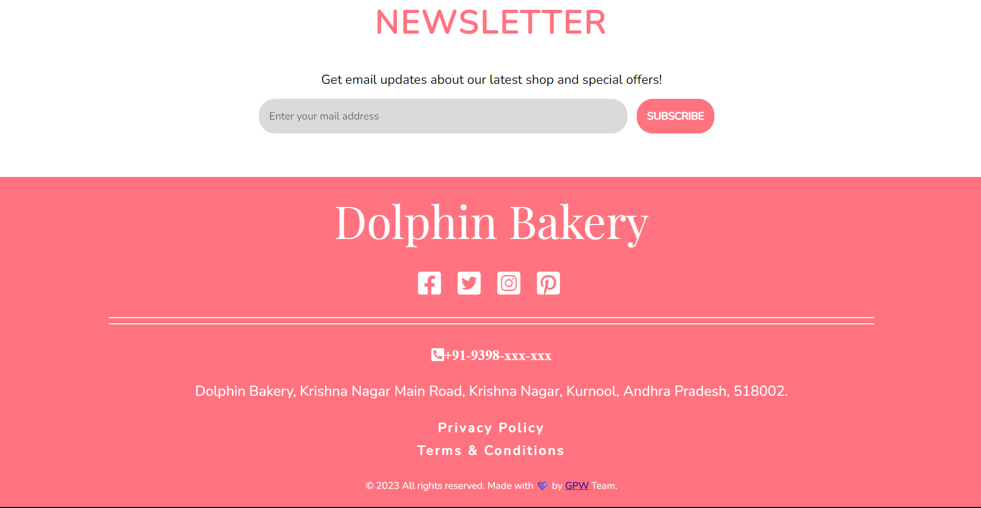

**3. DATABASE**

The database has been designed and normalised to keep a record of all the information about a particular user and a particular product. The database contains 11 tables, each of which stores details about a particular aspect of the online shop.

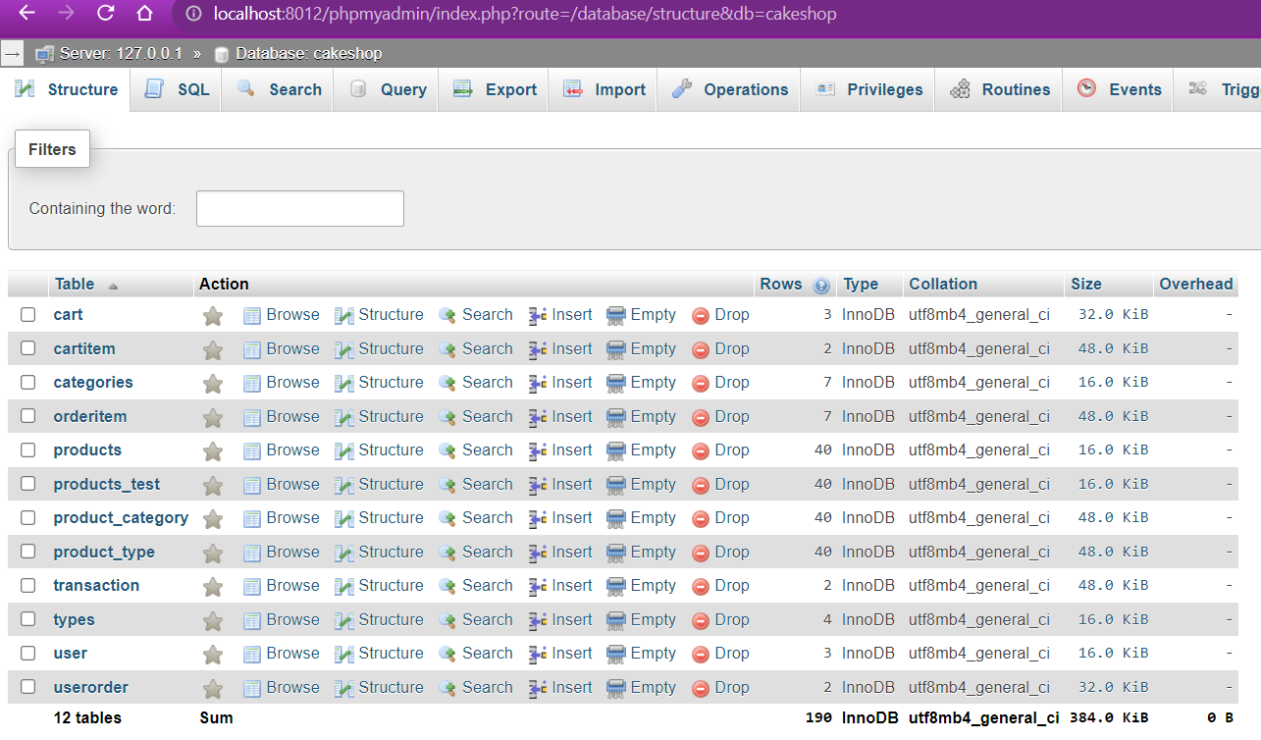

**Cart:**

The cart table connects the unique cartID which is generated to a particular user.

**cartItem:**

The cartItem table stores all the information about a particular product which the user has added to the shopping cart.

**categories, product_category:**

The categories table and product_category table links the different categories which a product can have.

**product_type, types:**

The product_type and types table links the different types which a product can have.

**orderitem, userOrder:**

The orderItem and userOrder table stores information about a particular order and a particular item which has been ordered once the user press checkout.

**Transaction:**

The transaction table is used to record a particular transaction which has taken place after the user has accepted an order.

**User:**

The user table stores all the information about a particular user including admin users.

**4. INDIVIDUAL REPORT**

We have implemented the Home page, About page, Contact Us page, Login Page, Registration Page, Forget Password Page, User Profile Page, Admin Panel Page and Send Mail To Subscribers Page.

* **Home Page:**

The home page has been implemented with HTML, CSS, Javascript, PHP and AJAX. It is divided in several parts whereby the user can have a global idea of what the product website is selling with details about the services offered as well as instructions on how to order on the website. The user also has an overview of the people involved in the company. These parts have been implemented with HTML and CSS. The contact form and newsletter have been implemented with HTML, CSS, JavaScript, PHP and AJAX. The contact form enables the user to send a mail to CakeWalk bakery mailbox(your email id). The field validation is done using JavaScript and once the fields have been validated, the data is send to a PHP file to be processed using AJAX such that there is no need to reload the page in order to get a confirmation of the completion of the mail sending process. In order to be able to send mail, the sendMail.ini and php.ini file in XAMPP folder have been modified such that mails can be sent from localhost.

The code snippet below execute the mail sending process using the ‘mail’ function in PHP: The newsletter also uses JavaScript to validate the correct email format and then the data is sent to a PHP file to be processed using AJAX. The function has been designed in such a way that only registered users can subscribe to a newsletter. If an invalid email or a non registered email is entered, the user will be prompted with an appropriate message. The google map has been integrated using a widget available from developers.google.com. Only the width and height have been modified to adapt it to our website.



* **Include Files:**

The sections listed below are all common across all pages. They have been implemented separately using the **_‘include’_** function in PHP. This prevents the same code from being implemented in each page making the website more difficult to maintain.

* Contact Us Form
* Newsletter Form
* Google Map
* Navigation Bar
* Mobile Navigation Bar
* Bottom Navigation Bar
* Footer
* **About Page:**

This page has been implemented with HTML and CSS. It contains more details about the people involved in the bakery CakeWalk. Information such as bakers, awards and more information about the CEO of the bakery are available. The contact form and newsletter forms are also available here.

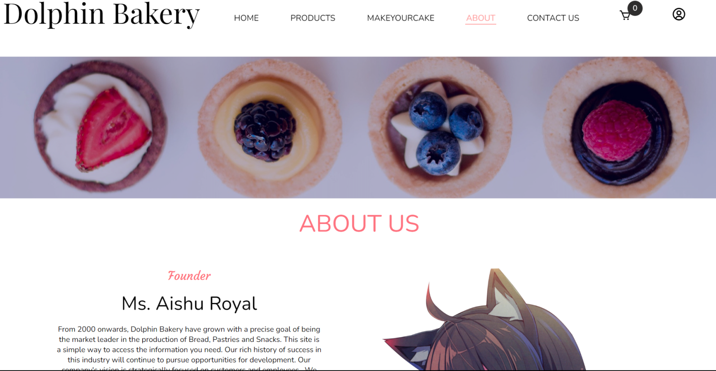

* **Contact Page:**

This contact page contains all the necessary information needed to get in contact with people at CakeWalk such as google map, contact form and newsletter.

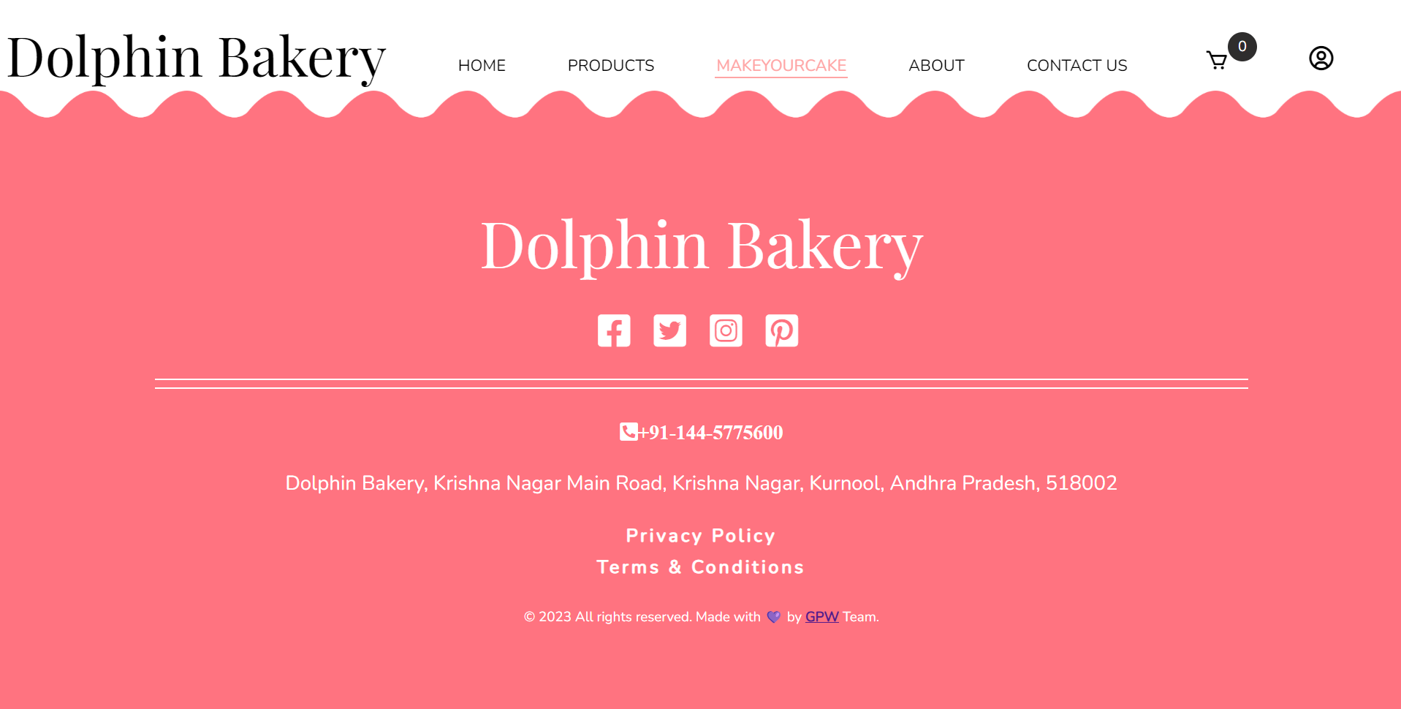

* **Login Page:**

The login page has been implemented using HTML, CSS and PHP. The form validation and processing are all done on the server side using PHP. The server checks if the username and password combination corresponds and only after confirmation gives the user access to his account. The function **_‘checkAccount.php’_** checks if the user is an admin and if he is, he will be redirected to the admin panel instead of the regular user profile account.

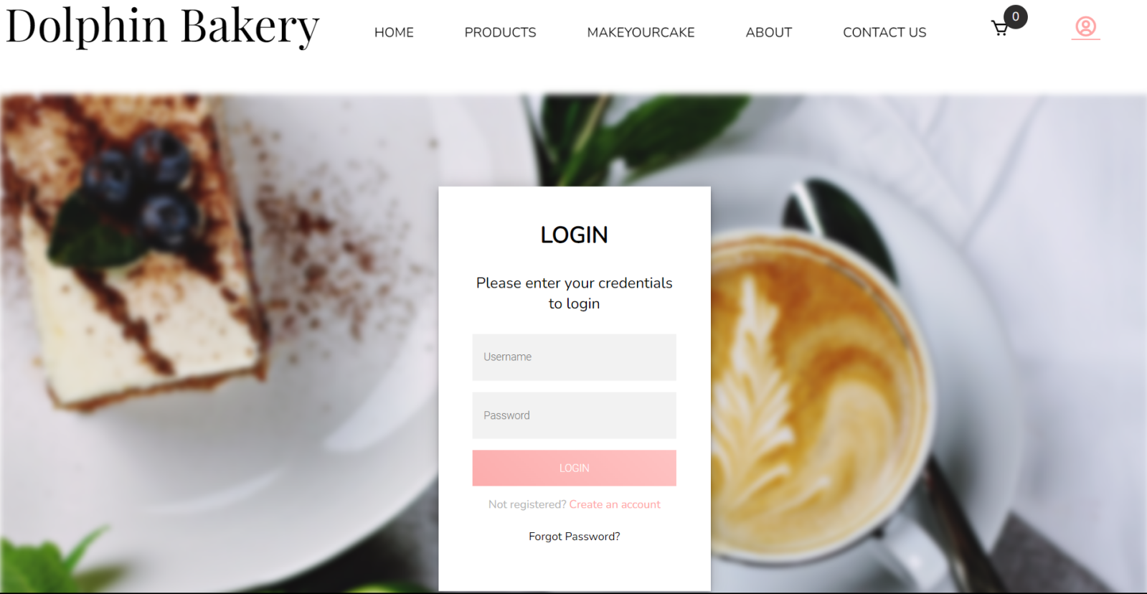

* **Forgot Password Page:**

The forgot password page has been implemented using HTML, CSS and PHP. All the form validations and processes are done on the server side using PHP. If the user has forgotten his password or username, using his email address, he can recover both. Once the button ‘RESET PASSWORD’ has been pressed, the user will receive an email containing his username and a randomized new password.

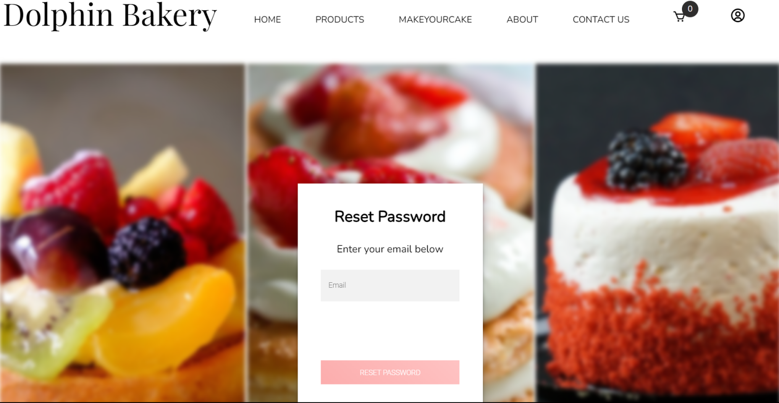

* **Registration Page:**

The registration page has been implemented using HTML, CSS and PHP. All the form validations and processes are done on the server side using PHP. The username and email are checked if they already exist in the database. If it is the case, an error message is prompted to the user. A google captcha checkbox is also used to prevent any type of bot attacks on the website. Once all the input have been validated, the user will receive an email with a link to validate the entered email during registration. The user will be able to login only after validating his email otherwise an error message will be prompted if the user tries to login before validating the email.

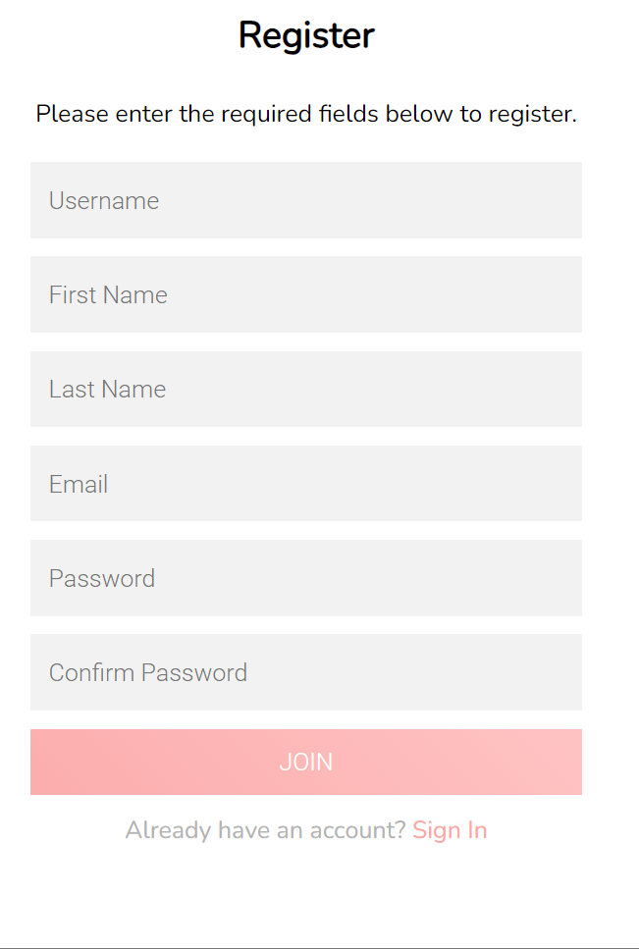

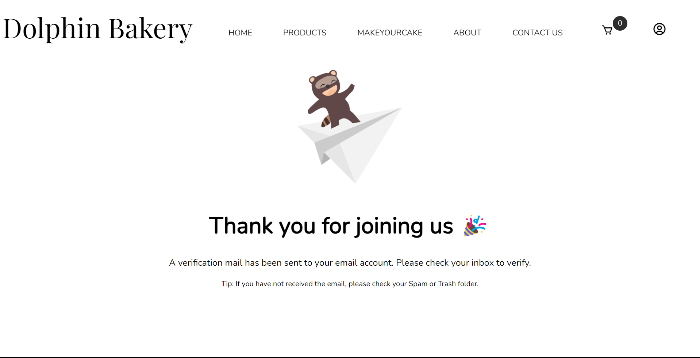

* **User Profile Page:**

This page has been implemented with HTML, CSS, Bootstrap and PHP. The user can view and edit his personal information and his password from this page. He can also delete his account from this page. The input validation are performed on the server side and if the correct input have been entered, the user can update his profile or change his password. The user is prompted with an appropriate message if the data has been successfully updated. The user can also logout using the logout button.

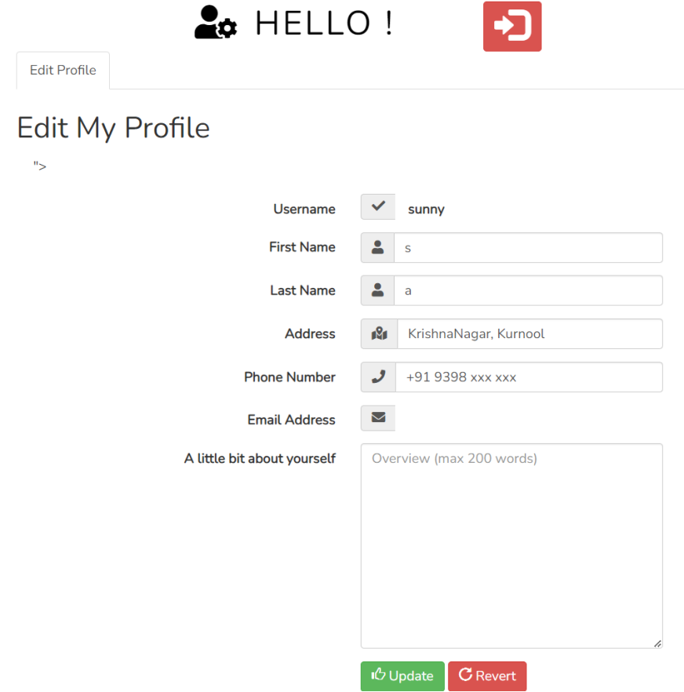

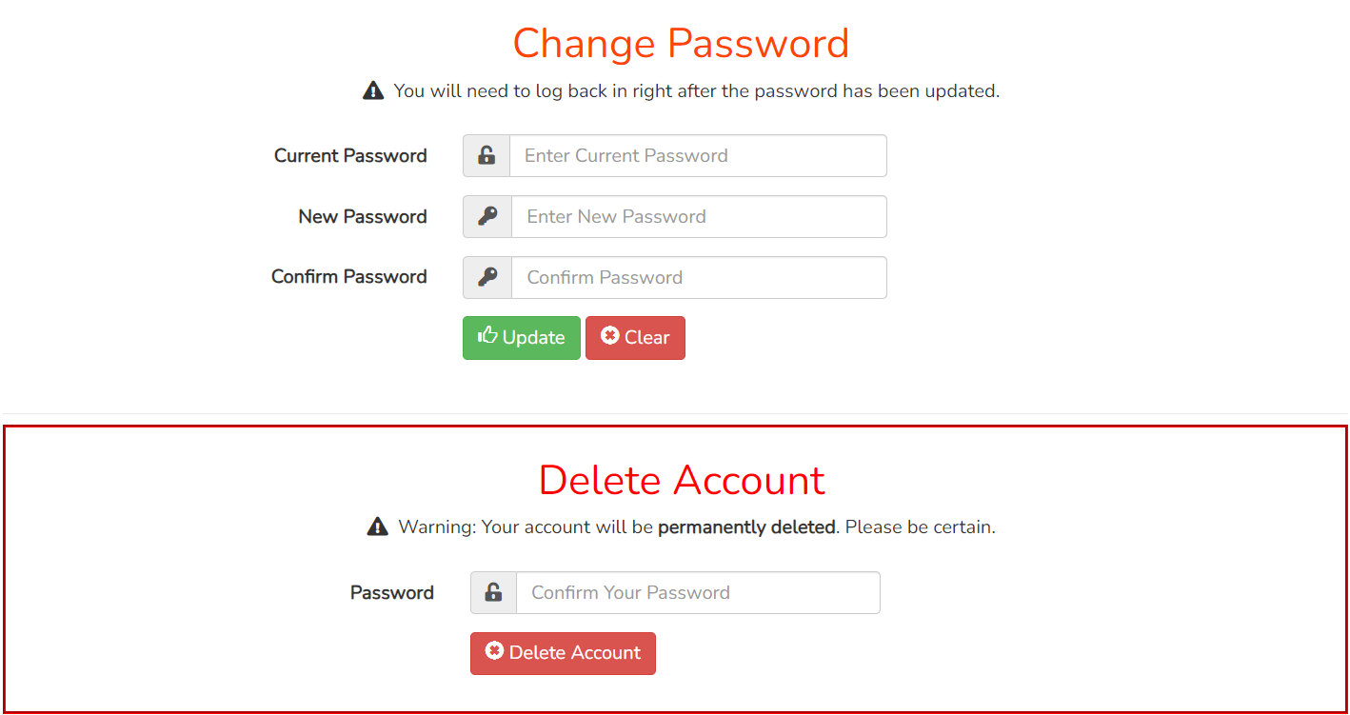

* **Admin Panel Page:**

This page has been implemented using HTML, CSS, Bootstrap, JavaScript and PHP. Here also the user can view, edit and update his information including his password and also delete his account. In addition to these options, an admin can also write and send an email to the subscribers directly from the website using a rich text editor implemented with JavaScript. The editor has been implemented using a widget named ‘summernote’ and it has been modified using the code snippet below to add additional options to the editor. The mail is sent using the code snippet below in PHP and automatically search for all subscribers in the database and add them in Bcc to the mail.

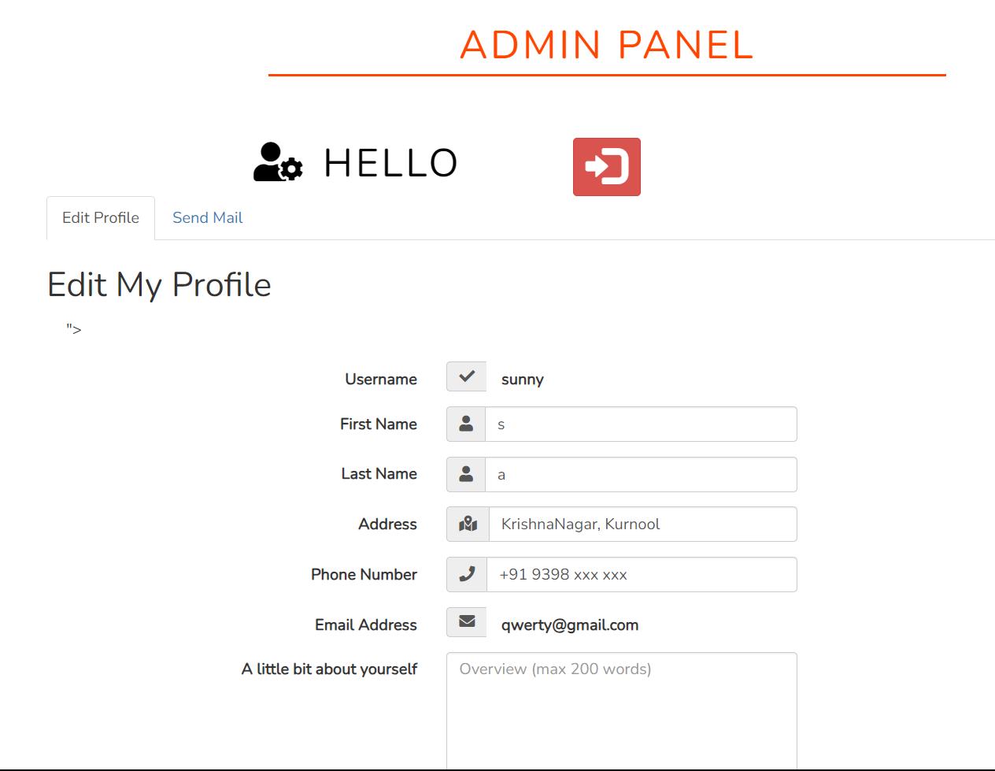

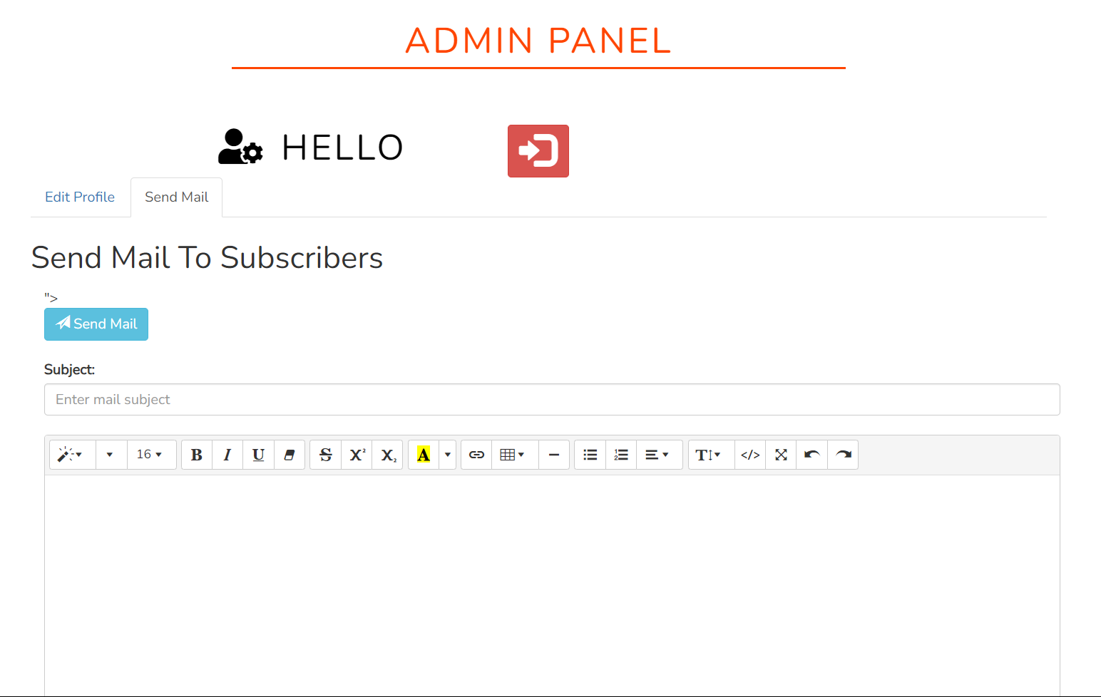

* **Responsiveness:**

This website has been designed in two parts using media queries in the CSS files. All pages have been designed twice. Once for mobile screen size and once for large screen size.



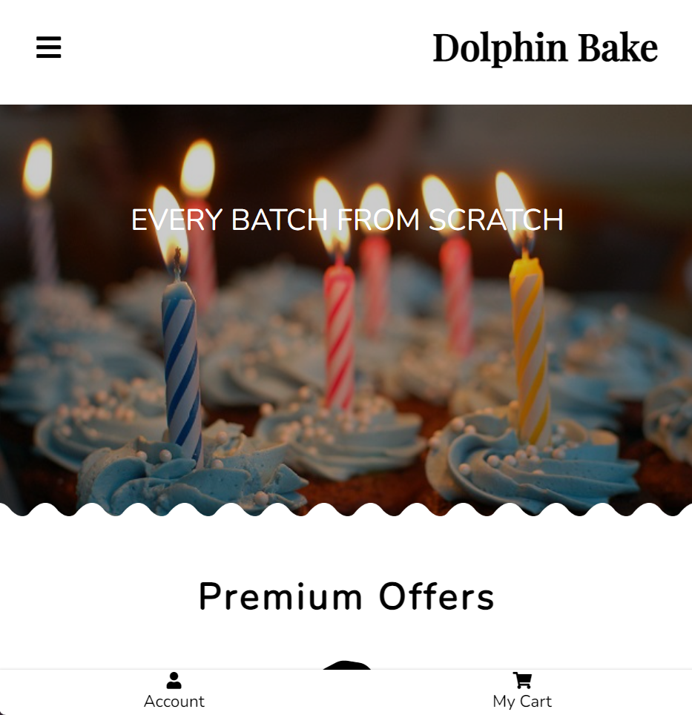

* **Page Access:**

In order to prevent anyone from accessing some crucial pages directly from the URL, a function **_‘checkAccess.php’_** has been designed to give access only to pages which have a constant named 'Access' defined in the page. Only pages which have been given access at the appropriate time will be displayed otherwise the page will display access denied. For example, trying to access **_‘userAccount.php’_** from the URL without signing in will display the following message: Access Denied!

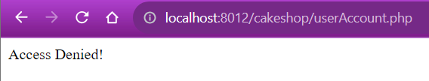

* **Each table in database**

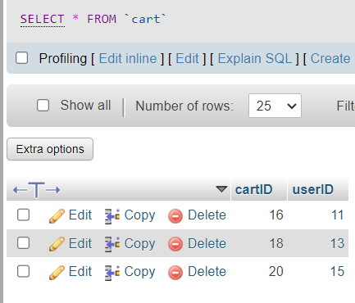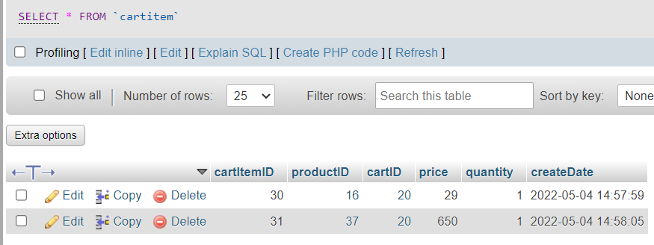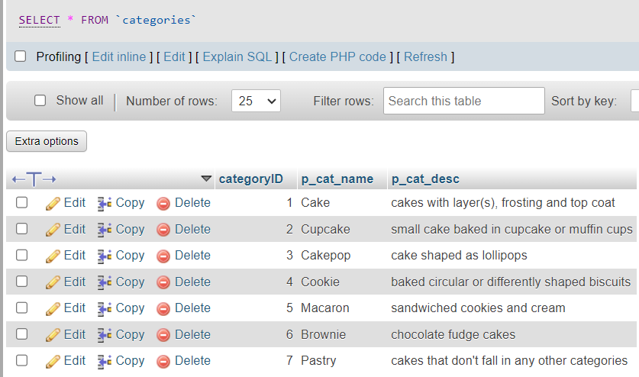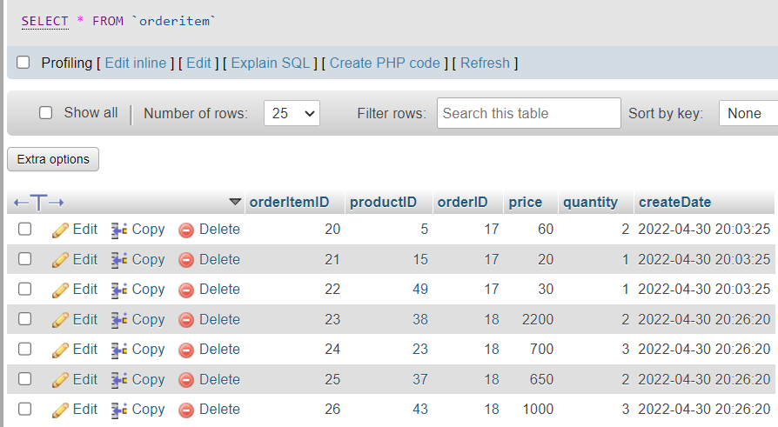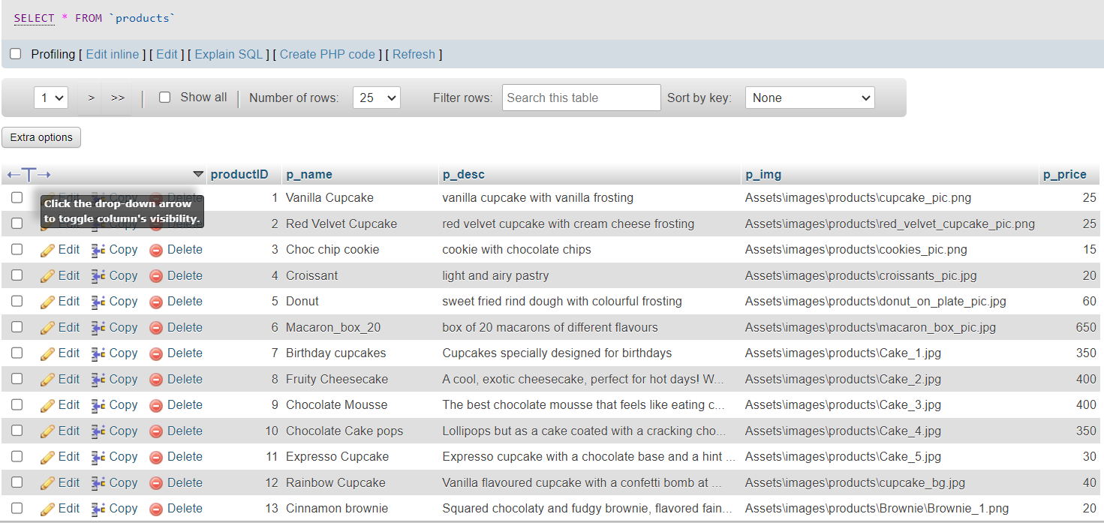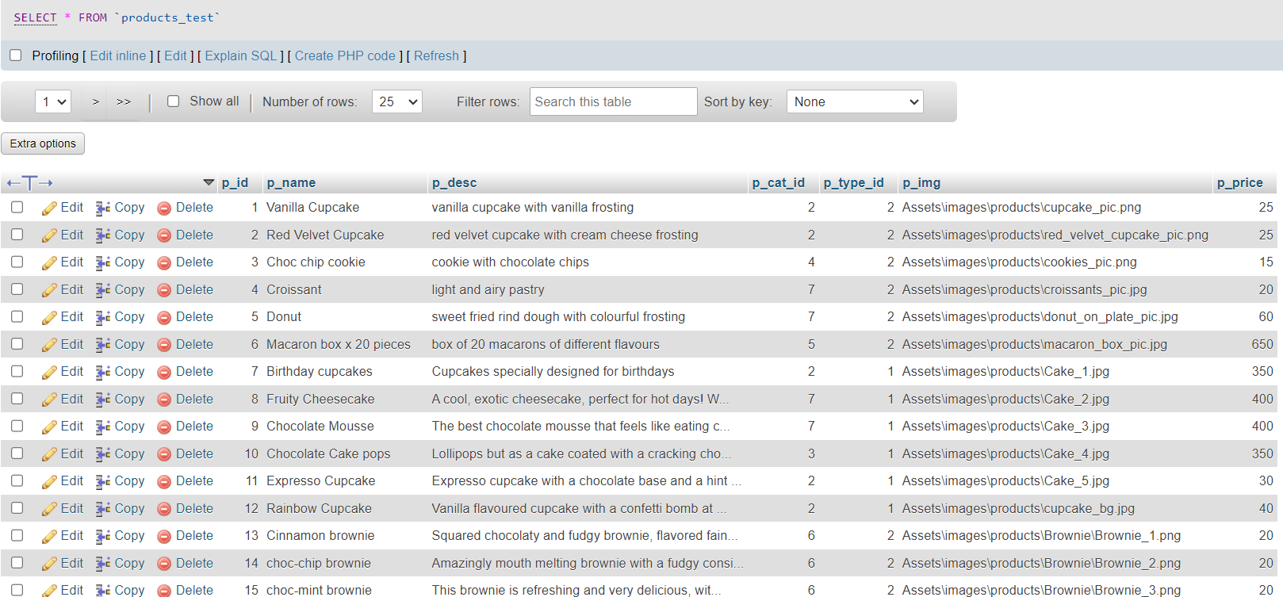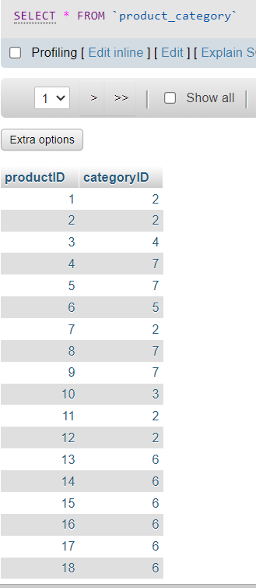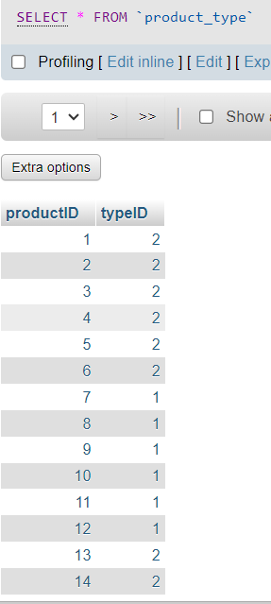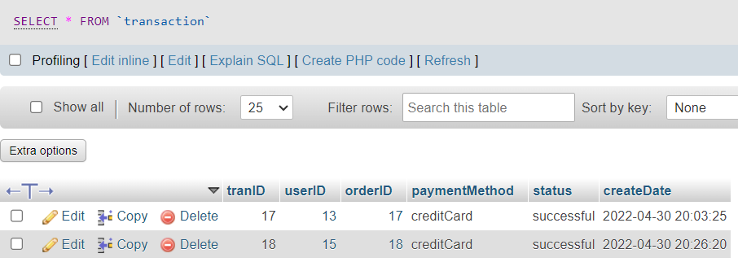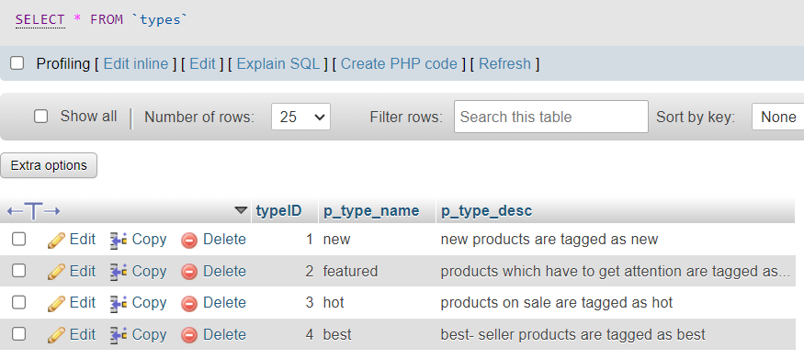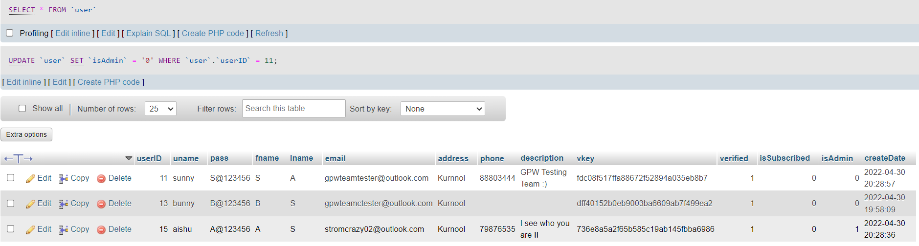

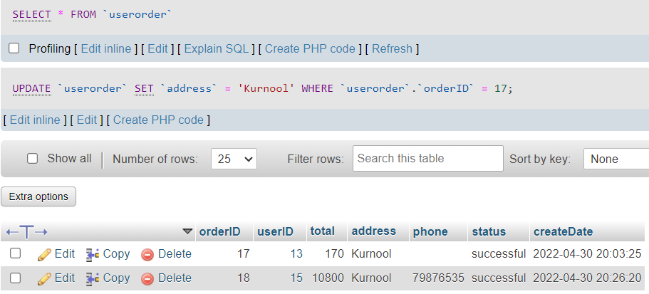

* **Main Code Snippets:**

**Start Session php**

<?php

    if(!isset($_SESSION))

    {

        session_start();

    }

?>

**Check Access php:**

<?php

    if(!defined('Access'))

    {

        exit('Access Denied!');

    }

?>

**Mobile Nav Bar php:**

<?php include "./AdditionalPHP/checkAccess.php"; ?>

<header class="main-header">

<nav class="main-nav">

        <input type="checkbox" id="check">

        <label for="check" class="checkbtn">

            <i class="fas fa-bars animate__animated animate__backInDown"></i>

        </label>

        <h1 class="business-name"><a href="index.html" class="animate__animated animate__backInDown">Dolphin Bake</a></h1>

        <ul>

            <li><a href="index.php" class="<?php if($page == 'index'){echo 'active';}?>" href="index.php">HOME</a></li>

            <li><a href="products.php" class="<?php if($page == 'products'){echo 'active';}?>" href="products.php">PRODUCTS</a></li>

            <li><a href="makeyourcake.php" class="<?php if($page == 'makeyourcake'){echo 'active';}?>" href="makeyourcake.php">MAKEYOURCAKE</a></li>

            <li><a href="about.php" class="<?php if($page == 'about'){echo 'active';}?>" href="about.php">ABOUT</a></li>

            <li><a href="contact.php" class="<?php if($page == 'contact'){echo 'active';}?>" href="contact.php">CONTACT US</a></li>

        </ul>

    </nav>

</header>

**PC Nav Bar php:**

<?php include "./AdditionalPHP/checkAccess.php"; ?>

<?php

    if(!isset($_SESSION))

    {

        session_start();

    }

    if(isset($_SESSION['uname'])){

        $href = 'checkAccount.php';

        $icon = 'bx bxs-user-circle';

        $cartHref = 'cart.php';

    } else {

        $href = 'login.php';

        $icon = 'bx bx-user-circle';

        $cartHref = 'login.php';

    }

?>

<header class="<?php if($page == 'index' || $page == 'products'){echo 'indexNav';}?> main-header-media1200">

<nav class="nav-media1200 main-nav-media1200">

        <h1 class="business-name-media1200"><a href="index.php" class="animate__animated animate__backInDown">Dolphin Bakery</a></h1>

        <ul class="animate__animated animate__backInDown">

            <li><a href="index.php" class="<?php if($page == 'index'){echo 'active';}?>">HOME</a></li>

            <li><a href="products.php" class="<?php if($page == 'products'){echo 'active';}?>">PRODUCTS</a></li>

            <li><a href="makeyourcake.php" class="<?php if($page == 'makeyourcake'){echo 'active';}?>">MAKEYOURCAKE</a></li>

            <li><a href="about.php" class="<?php if($page == 'about'){echo 'active';}?>">ABOUT</a></li>

            <li><a href="contact.php" class="<?php if($page == 'contact'){echo 'active';}?>">CONTACT US</a></li>

            <li><a href="<?php echo $cartHref;?>" class="<?php if($page == 'cart'){echo 'active';}?>"><i class="bx bx-cart nav__cart"></i></a>

            <p class="cart-number"><?php if(isset($_SESSION['item_quantity'])) {echo $_SESSION['item_quantity'];} else {echo "0";} ?></p></li>

            <li><a href="<?php echo $href;?>" class="<?php if($page == 'login' || $page == 'checkaccount'){echo 'active';}?> user-button"><i class="<?php echo $icon;?>"></i></a></li>

        </ul>

    </nav>

</header>

**Index php:**

<?php

    define('Access', TRUE);

    include "./AdditionalPHP/startSession.php";

?>

<!DOCTYPE html>

<html lang="en-MU">

    <head>

        <meta charset="utf-8">

        <title>Dolphin Bakery | Home</title>

        <meta name="viewport" content="width=device-width, initial-scale=1.0">

        <!--CSS File-->

        <link rel="stylesheet" type="text/css" href="Common.css">

        <link rel="stylesheet" type="text/css" href="Atish.css">

        <!-- Font Awesome -->

        <script src="https://kit.fontawesome.com/0e16635bd7.js" crossorigin="anonymous"></script>

        <!--BOXICONS-->

        <link href='https://unpkg.com/boxicons@2.0.7/css/boxicons.min.css' rel='stylesheet'>

        <!-- Animate CSS -->

        <link rel="stylesheet"href="https://cdnjs.cloudflare.com/ajax/libs/animate.css/4.1.1/animate.min.css"/>

        <script src="Javascript/swapWaveImg.js"></script>

        <!-- COUNTDOWN FUNCTION JAVASCRIPT BY SANJANA -->

        <script src = "Javascript/countdown_sales.js"></script>

</head>

    <body>

        <?php $page = 'index'?>

        <!--Start Navigation Bar-->

        <?php include './Includes/MobileNavBar.php';?>

        <!--End Navigation Bar-->

        <!--Start Navigation Bar @media 1200px-->

        <?php include './Includes/PcNavBar.php';?>

        <!--End Navigation Bar @media 1200px-->

        <!--Start Wave Image-->

        <div class="wave-image-group-media1200">

            <div class="wave-image-flip-media1200">

                <img src="Assets/images/1.index/NavBar_WaveWhiteThinFlip.png">

            </div>

        </div>

        <!--End Wave Image-->

        <!--Start Slideshow-->

        <div class="slideshow-container">

            <!-- Full-width images with number and caption text -->

            <div class="mySlides fade">

            <img src="Assets/images/1.index/Cake_1.jpg" style="width:100%">

            <div class="text">EVERY BATCH FROM SCRATCH</div>

            </div>

            <div class="mySlides fade">

            <img src="Assets/images/1.index/Cake_2.jpg" style="width:100%">

            <div class="text">WE IMPLEMENT SWEET DREAMS</div>

            </div>

            <div class="mySlides fade">

            <img src="Assets/images/1.index/Cake_3.jpg" style="width:100%">

            <div class="text">A LITTLE BLISS IN EVERY BITE</div>

            </div>

        </div>

        <script src="Javascript/SlideshowAuto.js"></script>

        <!--End Slideshow -->

        <!--Start Wave Image-->

        <div class="wave-image-group">

            <div class="wave-image">

                <img src="Assets/images/1.index/NavBar_WaveWhite.png">

            </div>

        </div>

        <!--End Wave Image-->

        <!--Start What You Can Do-->

        <div class="what-you-can-do">

            <div class="subtitle">

                <h2>Premium Offers</h2>

            </div>

            <div class="row">

                <div class="column">

                    <i class="fas fa-cookie"  style="color: black;"></i>

                    <span class="what-you-can-do-subtitle buy-our-cake">Freshly baked cakes</span>

                    <span class="what-you-can-do-text">Get a taste of our freshly prepared cakes by ordering online!</span>

                </div>

                <div class="column">

                    <i class="fas fa-mitten"  style="color: black;"></i>

                    <span class="what-you-can-do-subtitle customize-cake">Customize your cake</span>

                    <span class="what-you-can-do-text">You can customize your cake with your favourite glazing, toppings, color and more!</span>

                </div>

                <div class="column">

                    <i class="fas fa-boxes"  style="color: black;"></i>

                    <span class="what-you-can-do-subtitle create-box">Custom cake box</span>

                    <span class="what-you-can-do-text">You can add different types of cakes in a box and we deliver it to you!</span>

                </div>

            </div>

         </div>

        </div>

        <!--End What You Can Do-->

        <!--Start Special Offer-->

        <section class="offer-section">

            <div class="offer-bg">

                <div class="offer-data">

                    <div class="subtitle">

                        <h2>SPECIAL OFFER</h2>

                    </div>

                    <p class="offer-description">Extreme Independence Day Sales ends in: </p>

                    <p class="offer-description" id="countdown" style="font-family: Old Standard TT; font-size: 2rem;">Sales countdown</p>

                    <div class="subscribe-button-container">

                        <a href="products.php"><button class="subscribe-button" name="subscribe">SHOP NOW</button></a>

                    </div>

                </div>

            </div>

        </section>

        <!--End Special Offer-->

        <!--Start Wave Image-->

        <!-- <div class="wave-image-group">

            <div class="wave-image">

                <img src="Assets/images/1.index/NavBar_WaveWhite.png">

            </div>

        </div> -->

        <!--End Wave Image-->

        <!--Start How to Order-->

        <div class="how-to-order">

            <div class="subtitle">

                <h2 class="order-subtitle">Easy 3-Step Order</h2>

            </div>

            <div class="row" style="color: #FF7380FF;">

                <div class="column">

                  <i class="fas fa-birthday-cake"></i>

                  <p><b>Choose your cake</b></p>

                </div>

                <div class="column">

                  <i class="fas fa-cart-plus"></i>

                  <p><b>Add to cart</b></p>

                </div>

                <div class="column">

                  <i class="fas fa-money-check-alt"></i>

                  <p><b>Checkout</b></p>

                </div>

                 <div class="column">

                 <i class="fas fa-box-open"></i>

                 <p><b>We pack it up</b></p>

                </div>

                  <div class="column">

                  <i class="fas fa-shipping-fast"></i>

                  <p><b>Fast Delivery</b></p>

                </div>

            </div>

         </div>

        <!--End How to Order-->

        <!--Start Wave Image Flip-->

        <div class="wave-image-group">

            <div class="wave-image-flip how-to-order-wave">

                <img src="Assets/images/1.index/NavBar_WaveWhiteFlip.png">

            </div>

        </div>

        <!--End Wave Image Flip-->

        <!-- Start Our Baker-->

        <div class="our-baker">

            <div class="subtitle">

                <h2>Dolphin Bakery - Team</h2>

            </div>

            <div class="all-helper-info-index">

                <div class="helper-individual-index">

                    <div class="helper-group helper0">

                        <div class="helper-pic-group">

                            <div class="helper-pic"></div>

                        </div>

                        <div class = "helper-more-about">

                            <p class="name"><b>Ms. Aisha Royal</b></p>

                            <p class="hierarchy">CEO - CakeWalk Bakery</p>

                            <p class="description">I appreciate your interest in CakeWalk Bakery and I encourage you to check the website to learn more about CakeWalk's history, growth, and range of products.

<br>

<br>

<i> &#127872; We remain at your service. &#127872;</i></p>

                        </div>

                        <div class="helper-social-media">

                            <div class="social-media">

                                <span class="facebook">

                                    <a href=#><i class="fab fa-facebook-square"></i></a>

                                </span>

                                <span class="twitter">

                                    <a href=#><i class="fab fa-twitter-square"></i></a>

                                </span>

                                <span class="instagram">

                                    <a href=#><i class="fab fa-instagram-square"></i></a>

                                </span>

                                <span class="pinterest">

                                    <a href=#><i class="fab fa-pinterest-square"></i></a>

                                </span>

                            </div>

                        </div>

                    </div>

                </div>

                <div class="helper-individual-index">

                    <div class="helper-group helper1">

                        <div class="helper-pic-group">

                            <div class="helper-pic"></div>

                        </div>

                        <div class = "helper-more-about">

                            <p class="name"><b>Mr. Hemanth Reddy</b></p>

                            <p class="hierarchy">Co-Founder</p>

                            <p class="description">Thanks to your continuous support we were able to build our top-quality brand and continue to grow. We pride ourselves in our quality products and customer satisfaction, and guarantee that you will visit us back for more! &#127873;</p>

                        </div>

                        <div class="helper-social-media">

                            <div class="social-media">

                                <span class="facebook">

                                    <a href=#><i class="fab fa-facebook-square"></i></a>

                                </span>

                                <span class="twitter">

                                    <a href=#><i class="fab fa-twitter-square"></i></a>

                                </span>

                                <span class="instagram">

                                    <a href=#><i class="fab fa-instagram-square"></i></a>

                                </span>

                                <span class="pinterest">

                                    <a href=#><i class="fab fa-pinterest-square"></i></a>

                                </span>

                            </div>

                        </div>

                    </div>

                </div>

                <div class="helper-individual-index">

                    <div class="helper-group helper2">

                        <div class="helper-pic-group">

                            <div class="helper-pic"></div>

                        </div>

                        <div class = "helper-more-about">

                            <p class="name"><b>Ms. Greeshma Reddy</b></p>

                            <p class="hierarchy">Master Baker</p>

                            <p class="description">We are focused on providing top of the line, gourmet quality baked goods that won’t break the bank. At CakeWalk bakery we strive to create real guilt-free and delicious desserts that will put a smile on your face and leave you wanting more. &#127856;</p>

                        </div>

                        <div class="helper-social-media">

                            <div class="social-media">

                                <span class="facebook">

                                    <a href=#><i class="fab fa-facebook-square"></i></a>

                                </span>

                                <span class="twitter">

                                    <a href=#><i class="fab fa-twitter-square"></i></a>

                                </span>

                                <span class="instagram">

                                    <a href=#><i class="fab fa-instagram-square"></i></a>

                                </span>

                                <span class="pinterest">

                                    <a href=#><i class="fab fa-pinterest-square"></i></a>

                                </span>

                            </div>

                        </div>

                    </div>

                </div>

            </div>

        </div>

        <!-- End Our Baker-->

        <!-- Start Google Map-->

        <?php include './Includes/GoogleMap.php';?>

        <!-- End Google Map-->

        <!-- Start Contact Us -->

        <?php include './Includes/ContactUsForm.php';?>

        <!-- End Contact Us-->

        <!--Start Newsletter-->

        <?php include './Includes/NewsLetter.php';?>

        <!--End Newsletter-->

        <!--Start Footer-->

        <?php include './Includes/Footer.php';?>

        <!--End Footer-->

        <!-- Start Bottom Nav -->

        <?php include './Includes/MobileBottomNav.php';?>

        <!-- End Bottom Nav -->

    </body>

</html>

**Products php:**

<?php

    define('Access', TRUE);

    include "./AdditionalPHP/startSession.php";

?>

<!DOCTYPE html>

<html lang="en-MU">

<head>

    <meta charset="utf-8">

    <title>Dolphin Bakery | Products</title>

<meta name="viewport" content="width=device-width, initial-scale=1.0">

    <!--========== PHP CONNECTION TO DATABASE: CakeWalk ==========-->

    <?php

        include_once 'connection.php';

        include_once 'numOfItemsInCart.php';

?>

    <!--========== CSS FILE ==========-->

    <link rel="stylesheet" type="text/css" href="Common.css">

<link rel='stylesheet' type='text/css' href='Sanjana.css' />

    <!--========== BOOTSTRAP ==========-->

    <link href="https://cdn.jsdelivr.net/npm/bootstrap@5.0.0-beta1/dist/css/bootstrap.min.css" rel="stylesheet"

integrity="sha384-giJF6kkoqNQ00vy+HMDP7azOuL0xtbfIcaT9wjKHr8RbDVddVHyTfAAsrekwKmP1" crossorigin="anonymous">

    <!-- Bootstrap Core CSS -->

    <!-- <link rel="stylesheet" href="./bootstrap/css/bootstrap.css"> -->

<!-- <link rel='stylesheet' type='text/css' href='style.php' /> -->

    <!-- Font Awesome -->

    <script src="https://kit.fontawesome.com/0e16635bd7.js" crossorigin="anonymous"></script>

    <!-- Animate CSS -->

<link rel="stylesheet" href="https://cdnjs.cloudflare.com/ajax/libs/animate.css/4.1.1/animate.min.css" />

    <!--========== BOXICONS ==========-->

<link href='https://unpkg.com/boxicons@2.0.7/css/boxicons.min.css' rel='stylesheet'>

</head>

<!--___________________________________________________________________________-->

<body>

    <!--========== PHP QUERIES ==========-->

    <?php

        // $Q_fetch_featured = "SELECT * FROM products WHERE typeID = 2 ; ";//selects featured products

        // $Q_fetch_new =  "SELECT * FROM products WHERE typeID = 1 ; ";//selects new products

        // $Q_fetch_categories = "SELECT * FROM product_categories"; //selects all categories

        $Q_fetch_featured = "SELECT * FROM products INNER JOIN product_type ON products.productID = product_type.productID WHERE product_type.typeID = 2"; //selects featured products

        $Q_fetch_new = "SELECT * FROM products INNER JOIN product_type ON products.productID = product_type.productID WHERE product_type.typeID = 1"; //selects new products

        $Q_fetch_categories = "SELECT * FROM categories"; //selects all categories

    ?>

    <!--========== HEADER ==========-->

    <?php $page = 'products'?>

    <!--Start Navigation Bar-->

    <?php include './Includes/MobileNavBar.php';?>

<!--End Navigation Bar-->

    <!--Start Navigation Bar @media 1200px-->

    <?php include './Includes/PcNavBar.php';?>

<!--End Navigation Bar @media 1200px-->

    <!--Start Wave Image-->

    <!-- <div class="wave-image-group hide-wave">

        <div class="wave-image footer-wave">

            <img src="Assets/images/1.index/NavBar_WavePink.png">

        </div>

    </div> -->

    <!--End Wave Image-->

<!--___________________________________________________________________________-->

<main class="1-main">

        <!--========== OFFER 1 ==========-->

        <!-- <section class="offer section offer__top mt-2">

            <div class="offer__bg2 offer__1bg">

                <div class="offer__data ">

                    <h2 class="offer__title">50% OFF ON ALL CAKES!!!</h2>

                    <p class="offer__description">1st - 31st DECEMBER 2020<br />HURRY UP, DON'T MISS YOUR CHANCE!!!</p>

                    <a href="products.php" class="button button__round">SHOP NOW</a>

                </div>

            </div>

        </section> -->

        <!--Start Wave Flip Image-->

        <!-- <div class="">

            <div class="">

                <img src="Assets/images/1.index/NavBar_WavePinkFlip.png">

            </div>

        </div> -->

        <!--End Wave Flip Image-->

        <!--========== ATTEMPT TO QUERY FEATURED PRODUCTS ==========-->

        <section class="featured section" id="featured">

            <!--========== TITLE BANNER ==========-->

            <?php

                //FETCH PRODUCT BY CATEGORY

                $result_cat = mysqli_query($conn, $Q_fetch_categories);

            ?>

            <div class="row category-title">

                <div class="col">

                    <h2 class="category" id="small_title"></h2>

                    <h2 class="category-name " id="big_title"></h2>

                </div>

                <!--========== SORT BY BUTTON ==========-->

                <div class="dropdown col-auto">

                    <button class="dropbtn button" id="cat-but">Sort by &nbsp<i class='bx bxs-down-arrow drop-arrow'></i></button>

                    <div class="dropdown-content">

                        <a href="#" onclick="sortby_products(1)">Price: low to high</a>

                        <a href="#" onclick="sortby_products(2)">Price: high to low</a>

                    </div>

                </div>

                <!--========== CATEGORIES BUTTON ==========-->

                <div class="dropdown col-auto">

                    <button class="dropbtn button" id="cat-but">Categories &nbsp<i class='bx bxs-down-arrow drop-arrow'></i></button>

                    <div class="dropdown-content">

                        <?php

                        while($row_categories = mysqli_fetch_assoc($result_cat)){

                            $categoryID = $row_categories['categoryID'];

                            $p_cat_name = $row_categories['p_cat_name'];

                            ?>

                            <a href="#" onclick="display_products_by_cat_id(<?php echo $categoryID; ?>, '<?php echo $p_cat_name; ?>'); " ><?php echo $p_cat_name; ?></a>

                            <!-- <input type="submit" onclick="display_products_by_cat_id(<?php echo $categoryID; ?>)" value="<?php echo $row_categories['p_cat_name']; ?>"> -->

                            <?php

                        }

                        ?>

                    </div>

                </div>

            </div>

            <div id="result" class="featured__container bd-grid mt-4">

                <!-- PRODUCTS BY CATEGORY  -->

                <!-- SORTED PRODUCTS  -->

            </div>

        </section>

        <!--========== OFFER 2 ==========-->

        <section class="offer section">

            <div class="offer__bg">

                <div class="offer__data">

                    <h2 class="offer__title">Special Offer</h2>

                    <p class="offer__description">Extreme Independence Day Sales this month only!</p>

                    <a href="#" class="button button__round">SHOP NOW</a>

                </div>

            </div>

        </section>

        <!--========== ATTEMPT TO QUERY NEW PRODUCTS ==========-->

        <section class="new section" id="new">

        <div class="row category-title">

                <div class="col">

                    <h2 class="category" id="small_title2"></h2>

                    <h2 class="category-name " id="big_title2"></h2>

                </div>

        </div>

            <div class="new__container bd-grid" id="result2">

            </div>

        </section>

        <!--Start Footer-->

        <?php include './Includes/Footer.php';?>

        <!--End Footer-->

        <!-- Start Bottom Nav -->

        <?php include './Includes/MobileBottomNav.php';?>

        <!-- End Bottom Nav -->

    <!--___________________________________________________________________________-->

    <!--========== JAVASCRIPT ==========-->

            <!-- IMPLEMENTING AJAX WITH JAVASCRIPT -->

            <script>

                //CATEGORIES FUNCTION - DISPLAY WITHOUT LOAD

                function display_products_by_cat_id(cat_id, cat_name){

                    var xhttp;

                    //AJAX

                    console.log('entered ajax');

                    xhttp = new XMLHttpRequest();

                    xhttp.onreadystatechange = function() {

                        if (this.readyState == 4 && this.status == 200) {

                            console.log('ready');

                            document.getElementById("result").innerHTML = this.responseText;

                        }

                    };

                    xhttp.open("GET", "category_search.php?cat_id="+cat_id, true);

                    xhttp.send();

                    console.log('sent');

                    //CHANGES TITLE

                    document.getElementById('small_title').innerHTML = 'CATEGORY';

                    document.getElementById('big_title').innerHTML = cat_name;

                }

                //SORT BY FUNCTION - DISPLAY WITHOUT LOAD WHERE ID = RESULT

                function sortby_products(sort_num){

                    var xhttp;

                      //AJAX

                      console.log('entered ajax sortby');

                    xhttp = new XMLHttpRequest();

                    xhttp.onreadystatechange = function() {

                        if (this.readyState == 4 && this.status == 200) {

                            console.log('ready sortby');

                            document.getElementById("result").innerHTML = this.responseText;

                        }

                    };

                    xhttp.open("GET", "sortby_search.php?sortby="+sort_num, true);

                    xhttp.send();

                    console.log('sent sortby');

                    //CHANGES TITLE

                    document.getElementById('small_title').innerHTML = 'SORT BY PRICE';

                    if(sort_num == 1){

                        document.getElementById('big_title').innerHTML = 'low to high';

                    }

                    else if(sort_num ==2){

                        document.getElementById('big_title').innerHTML = 'high to low';

                    }

                }

                //TYPE OF PRODUCTS FUNCTION - DISPLAY WITHOUT LOAD

                function display_products_by_type(p_type){

                    var xhttp;

                    //AJAX

                    console.log('entered ajax');

                    xhttp = new XMLHttpRequest();

                    xhttp.onreadystatechange = function() {

                        if (this.readyState == 4 && this.status == 200) {

                            console.log('ready');

                            document.getElementById("result").innerHTML = this.responseText;

                        }

                    };

                    xhttp.open("GET", "products_by_type_search.php?p_type="+p_type, true);

                    xhttp.send();

                    console.log('sent');

                    //CHANGES TITLE

                    if(p_type==1){

                        document.getElementById('small_title').innerHTML = 'new';

                    }

                    else  if(p_type==2){

                        document.getElementById('small_title').innerHTML = 'featured';

                    }

                    else  if(p_type==3){

                        document.getElementById('small_title').innerHTML = 'sales';

                    }

                    else  if(p_type==4){

                        document.getElementById('small_title').innerHTML = 'best-seller';

                    }

                    //BIG TITLE

                    document.getElementById('big_title').innerHTML = 'PRODUCTS';

                }

                //TYPE OF PRODUCTS FUNCTION - DISPLAY WITHOUT LOAD WHERE ID = RESULT2

                function display_products_by_type_second(p_type){

                    var xhttp;

                    //AJAX

                    console.log('entered ajax');

                    xhttp = new XMLHttpRequest();

                    xhttp.onreadystatechange = function() {

                        if (this.readyState == 4 && this.status == 200) {

                            console.log('ready');

                            document.getElementById("result2").innerHTML = this.responseText;

                        }

                    };

                    xhttp.open("GET", "products_by_type_search.php?p_type="+p_type, true);

                    xhttp.send();

                    console.log('sent');

                    //CHANGES TITLE

                    if(p_type==1){

                        document.getElementById('small_title2').innerHTML = 'new';

                    }

                    else  if(p_type==2){

                        document.getElementById('small_title2').innerHTML = 'featured';

                    }

                    else  if(p_type==3){

                        document.getElementById('small_title2').innerHTML = 'sales';

                    }

                    else  if(p_type==4){

                        document.getElementById('small_title2').innerHTML = 'best-seller';

                    }

                    //BIG TITLE

                    document.getElementById('big_title2').innerHTML = 'PRODUCTS';

                }

                //LAUNCHING FEATURED PRODUCTS FUNCTION

                display_products_by_type(2); // 2 --> featured

                //LAUNCHING NEW PRODUCTS FUNCTION

                display_products_by_type_second(1); // 1 --> new

            </script>

</body>

</html>

**Make Your Cake php:**

<?php

    define('Access', TRUE);

    include "./AdditionalPHP/startSession.php";

?>

<!DOCTYPE html>

<html lang="en-MU">

    <head>

        <meta charset="utf-8">

        <title>Dolphin Bakery | Make Your Cake</title>

        <meta name="viewport" content="width=device-width, initial-scale=1.0">

        <!--CSS File-->

        <link rel="stylesheet" type="text/css" href="Common.css">

        <link rel="stylesheet" type="text/css" href="Atish.css">

        <!-- Font Awesome -->

        <script src="https://kit.fontawesome.com/0e16635bd7.js" crossorigin="anonymous"></script>

        <!--BOXICONS-->

        <link href='https://unpkg.com/boxicons@2.0.7/css/boxicons.min.css' rel='stylesheet'>

        <!-- Animate CSS -->

        <link rel="stylesheet"href="https://cdnjs.cloudflare.com/ajax/libs/animate.css/4.1.1/animate.min.css"/>

    </head>

    <body>

        <?php $page = 'makeyourcake';?>

        <!--Start Navigation Bar-->

        <?php include './Includes/MobileNavBar.php';?>

        <!--End Navigation Bar-->

        <!--Start Navigation Bar @media 1200px-->

        <?php include './Includes/PcNavBar.php';?>

        <!--End Navigation Bar @media 1200px-->

        <!--Start Wave Image-->

        <div class="wave-image-group">

            <div class="wave-image footer-wave">

                <img src="Assets/images/1.index/NavBar_WavePink.png">

            </div>

        </div>

        <!--End Wave Image-->

        <!--Start Footer-->

        <footer class="footer-group">

            <div class="footer">

                <div class="logo">

                    <span class="logo-name">Dolphin Bakery</span>

                </div>

                <div class="social-media">

                    <span class="facebook">

                        <a href=#><i class="fab fa-facebook-square"></i></a>

                    </span>

                    <span class="twitter">

                        <a href=#><i class="fab fa-twitter-square"></i></a>

                    </span>

                    <span class="instagram">

                        <a href=#><i class="fab fa-instagram-square"></i></a>

                    </span>

                    <span class="pinterest">

                        <a href=#><i class="fab fa-pinterest-square"></i></a>

                    </span>

                </div>

                <hr size="2px" width="80%" color="white">

                <hr size="2px" width="80%" color="white">

            <div class="contact-links">

            <span class="phone"><i class="fas fa-phone-square-alt">+91-144-5775600</i></span>

            <span class="address">Dolphin Bakery, Krishna Nagar Main Road, Krishna Nagar, Kurnool, Andhra Pradesh, 518002</span>

        </div>

        <div class="legal-links">

            <span class="privacy-policy"><b><a href=#>Privacy Policy</a></b></span>

            <span class="term-of-use"><b><a href=#>Terms & Conditions</a></b></span>

        </div>

        <div class="copyright">

            <span class="copyright-text">&#169; <?php echo date("Y"); ?> All rights reserved. Made with &#x1F49C; by <b><a href="https://www.youtube.com/channel/UC4_6-VSWBw_QHMyjrDDEvVQ"> GPW</a></b> Team.</span>

        </div>

            </div>

        </footer>

        <!--End Footer-->

        <!-- Start Bottom Nav -->

        <div class="bottom-nav-group">

            <nav class="bottom-nav">

                <a href="login.html" class="bottom-nav-link">

                    <i class="fas fa-user bottom-nav-icon" ></i>

                    <span class="bottom-nav-text">Account</span>

                </a>

                <a href="#" class="bottom-nav-link">

                    <i class="fas fa-search"></i>

                    <span class="bottom-nav-text">Search</span>

                </a>

                <a href="#" class="bottom-nav-link">

                    <i class="fas fa-shopping-cart"></i>

                    <span class="bottom-nav-text">My Cart</span>

                </a>

            </nav>

        </div>

        <!-- End Bottom Nav -->

    </body>

</html>

**About php:**

<?php

    define('Access', TRUE);

    include "./AdditionalPHP/startSession.php";

?>

<!DOCTYPE html>

<html lang="en-MU">

    <head>

        <meta charset="utf-8">

        <title>Dolphin Bakery | About Us</title>

        <meta name="viewport" content="width=device-width, initial-scale=1.0">

        <!--CSS File-->

        <link rel="stylesheet" type="text/css" href="Common.css">

        <link rel="stylesheet" type="text/css" href="Atish.css">

        <!-- Font Awesome -->

        <script src="https://kit.fontawesome.com/0e16635bd7.js" crossorigin="anonymous"></script>

        <!--BOXICONS-->

        <link href='https://unpkg.com/boxicons@2.0.7/css/boxicons.min.css' rel='stylesheet'>

        <!-- Animate CSS -->

        <link rel="stylesheet"href="https://cdnjs.cloudflare.com/ajax/libs/animate.css/4.1.1/animate.min.css"/>

    </head>

    <body>

        <?php $page = 'about';?>

        <!--Start Navigation Bar-->

        <?php include './Includes/MobileNavBar.php';?>

        <!--End Navigation Bar-->

        <!--Start Navigation Bar @media 1200px-->

        <?php include './Includes/PcNavBar.php';?>

        <!--End Navigation Bar @media 1200px-->

        <!--Start Page Header-->

        <div class="about-us-header">

            <div class="banner-group">

                <div class="banner"></div>

            </div>

            <div class="about-us-subtitle">

                <span>ABOUT US</span>

            </div>

        </div>

        <!--End Page Header-->

        <!--Start Baker Info-->

        <div class="baker-info-group">

            <div class="baker-info-container">

                <div class="baker-info-text">

                    <div class="baker-info-title">

                        <span>Founder</span>

                    </div>

                    <div class="baker-name">

                        <span>Ms. Aishu Royal</span>

                    </div>

                    <div class="baker-description">

                        <p>

From ​2000 onwards, Dolphin Bakery have grown with a precise goal of being the market leader in the production of Bread, Pastries and Snacks. This site is a simple way to access the information you need.

Our rich history of success in this industry will continue to pursue opportunities for development. Our company's vision is strategically focused on customers and employees ​. We have many reasons to be  proud of our results.

I ​can assure you of the unlimited commitment of our teams at every level. Innovations are shared within units to support Dolphin Bakery's culture of continuous improvement. This would enable us to meet the Region's long-term challenges.

I appreciate your interest in Dolphin Bakery Bakery and I encourage you to check the website to learn more about Dolphin Bakery's history, growth, and range of products.

<br>

<i>We remain at your service.</i> ​</p>

                    </div>

                    <div class="baker-signature">

                        <div class="signature-photo"></div>

                    </div>

                    <div class="baker-position">

                        <span>CEO - Dolphin Bakery</span>

                    </div>

                </div>

                <div class="baker-photo-group">

                    <div class="baker-photo"></div>

                </div>

            </div>

        </div>

        <!--End Baker Info-->

        <!--Start Awards-->

        <div class="award-section">

            <div class="award-title">

                <span>Dolphin Bakery - Hall of Fame</span>

            </div>

            <div class="subtitle">

                <h2>AWARDS WON</h2>

            </div>

            <div class="award-badge-container">

                <div class="award-badge-group">

                    <div class="badge badge1">

                        <div class="badge-photo-group">

                            <div class="badge-photo"></div>

                        </div>

                        <div class="badge-info">

                            <span class="badge-title">Bakery of the year</span>

                            <span class="badge-date">2017-2018</span>

                            <p class="badge-description">Krishna.Dev_Royal started Dolphin Bakery in Kurnool in early 2000. The bakery specialises in sourdough, cake and pastry all produced in house by the 30-strong team. “She’s really at the top of her game and the products she makes are all of a benchmark quality, whether destined for her retail or wholesale customers,” the judges said.</p>

                        </div>

                    </div>

                </div>

                <div class="award-badge-group">

                    <div class="badge badge2">

                        <div class="badge-photo-group">

                            <div class="badge-photo"></div>

                        </div>

                        <div class="badge-info">

                            <span class="badge-title">Team of the Year</span>

                            <span class="badge-date">2019-2020</span>

                            <p class="badge-description">The camaraderie and working environment at our Dolphin Bakery, which specialises in extended shelf life doughnuts, bowled the judges over. Our team is headed up by MD and founder Aisha Master, and supported by operations manager Sunny Royal and Bunny Royal in admin.</p>

                        </div>

                    </div>

                </div>

                <div class="award-badge-group">

                    <div class="badge badge3">

                        <div class="badge-photo-group">

                            <div class="badge-photo"></div>

                        </div>

                        <div class="badge-info">

                            <span class="badge-title">Rising Star Award</span>

                            <span class="badge-date">2021-2022</span>

                            <p class="badge-description">Aisha - Our Co-Founder and lead baker, boasts over 20-year career in the baking industry during which time he has worked for trade bodies, craft bakeries, in-store bakeries and at Chennai and Bangalore. He was described as “an exemplary member of the baking community” by the judges.</p>

                        </div>

                    </div>

                </div>

            </div>

        </div>

        <!--End Awards-->

        <!--Start Team Info-->

        <div class="team-section">

            <div class="team-title">

                <span>Golden Hands in Dolphin Bakery</span>

            </div>

            <div class="subtitle">

                <h2>OUR TEAM</h2>

            </div>

            <div class="all-helper-info">

                <div class="helper-individual">

                    <div class="helper-group helper1">

                        <div class="helper-pic-group">

                            <div class="helper-pic"></div>

                        </div>

                        <div class = "helper-more-about">

                            <p class="name"><b>Mr. Hemanth Reddy</b></p>

                            <p class="hierarchy">Co-Founder</p>

                            <p class="description">It started as a small confectionery store to turn into the biggest supplier of quality premium bread. Our history of success in the baking industry is solely built on our commitment to excellence in the delivery of products. We are highly dedicated to providing our customers with an extinguished and nourishing experience to answer their hunger's call by passionately offering superior value. Our aim is to deliver what we promise not only to our customers but to all the stakeholders starting with our employees who are our most valuable assets.Thanks to our team of highly qualified and trained craftsmen we translate strategies into achievements and dreams into reality.Thanks to your continuous support we were able to build our top-quality brand and continue to grow. We pride ourselves in our quality products and customer satisfaction, and guarantee you will come back for more!

                        </div>

                        <div class="helper-social-media">

                            <div class="social-media">

                                <span class="facebook">

                                    <a href=#><i class="fab fa-facebook-square"></i></a>

                                </span>

                                <span class="twitter">

                                    <a href=#><i class="fab fa-twitter-square"></i></a>

                                </span>

                                <span class="instagram">

                                    <a href=#><i class="fab fa-instagram-square"></i></a>

                                </span>

                                <span class="pinterest">

                                    <a href=#><i class="fab fa-pinterest-square"></i></a>

                                </span>

                            </div>

                        </div>

                    </div>

                </div>

                <div class="helper-individual">

                    <div class="helper-group helper2">

                        <div class="helper-pic-group">

                            <div class="helper-pic"></div>

                        </div>

                        <div class = "helper-more-about">

                            <p class="name"><b>Ms. Greeshma Reddy</b></p>

                            <p class="hierarchy">Master Baker</p>

                            <p class="description">Our simple and warm bake shop offers a vast array of delicious breads and pastries that will impress you – from rye bread, croissants, pies, and cakes- all baked daily, fresh each day, fresh the whole day!

                                We are dedicated to provide consistently excellent and professionally-made food that is why we have a clean and efficient bakery and we only use high quality ingredients from trusted local suppliers. At CakeWalk bakery we strive to create real guilt-free and delicious desserts that will put a smile on your face and leave you wanting more.

                                We are one of the few bakeries in Chennai to offer an extensive line of delicious gluten-free products that have the same flavor and texture as their counterparts. We are focused on providing top of the line, gourmet quality baked goods that won’t break the bank.</p>

                        </div>

                        <div class="helper-social-media">

                            <div class="social-media">

                                <span class="facebook">

                                    <a href=#><i class="fab fa-facebook-square"></i></a>

                                </span>

                                <span class="twitter">

                                    <a href=#><i class="fab fa-twitter-square"></i></a>

                                </span>

                                <span class="instagram">

                                    <a href=#><i class="fab fa-instagram-square"></i></a>

                                </span>

                                <span class="pinterest">

                                    <a href=#><i class="fab fa-pinterest-square"></i></a>

                                </span>

                            </div>

                        </div>

                    </div>

                </div>

            </div>

        </div>

        <!--End Team Info-->

        <!-- Start Google Map-->

        <?php include './Includes/GoogleMap.php';?>

        <!-- End Google Map-->

        <!-- Start Contact Us -->

        <?php include './Includes/ContactUsForm.php';?>

        <!-- End Contact Us-->

        <!--Start Newsletter-->

        <?php include './Includes/NewsLetter.php';?>

        <!--End Newsletter-->

        <!--Start Footer-->

        <?php include './Includes/Footer.php';?>

        <!--End Footer-->

        <!-- Start Bottom Nav -->

        <?php include './Includes/MobileBottomNav.php';?>

        <!-- End Bottom Nav -->

    </body>

</html>

**Contact php:**

<?php

    define('Access', TRUE);

    include "./AdditionalPHP/startSession.php";

?>

<!DOCTYPE html>

<html lang="en-MU">

    <head>

        <meta charset="utf-8">

        <title>Dolphin Bakery | Contact Us</title>

        <meta name="viewport" content="width=device-width, initial-scale=1.0">

        <!--CSS File-->

        <link rel="stylesheet" type="text/css" href="Common.css">

        <link rel="stylesheet" type="text/css" href="Atish.css">

        <!-- Font Awesome -->

        <script src="https://kit.fontawesome.com/0e16635bd7.js" crossorigin="anonymous"></script>

        <!--BOXICONS-->

        <link href='https://unpkg.com/boxicons@2.0.7/css/boxicons.min.css' rel='stylesheet'>

        <!-- Animate CSS -->

        <link rel="stylesheet"href="https://cdnjs.cloudflare.com/ajax/libs/animate.css/4.1.1/animate.min.css"/>

    </head>

    <body>

        <?php $page = 'contact';?>

        <!--Start Navigation Bar-->

        <?php include './Includes/MobileNavBar.php';?>

        <!--End Navigation Bar-->

        <!--Start Navigation Bar @media 1200px-->

        <?php include './Includes/PcNavBar.php';?>

        <!--End Navigation Bar @media 1200px-->

        <!--Start Page Header-->

        <div class="about-us-header contact-us-header">

            <div class="banner-group">

                <div class="banner"></div>

            </div>

        </div>

        <!--End Page Header-->

         <!-- Start Google Map-->

         <?php include './Includes/GoogleMap.php';?>

        <!-- End Google Map-->

        <!-- Start Contact Us -->

        <?php include './Includes/ContactUsForm.php';?>

        <!-- End Contact Us-->

        <!--Start Newsletter-->

        <?php include './Includes/NewsLetter.php';?>

        <!--End Newsletter-->

        <!--Start Footer-->

        <?php include './Includes/Footer.php';?>

        <!--End Footer-->

        <!-- Start Bottom Nav -->

        <?php include './Includes/MobileBottomNav.php';?>

        <!-- End Bottom Nav -->

    </body>

</html>

**Google map php:**

<?php include "./AdditionalPHP/checkAccess.php"; ?>

<div class="map">

    <div class="subtitle">

        <h2>LOCATE US</h2>

</div>

    <div class="google-map">

        <iframe src="https://www.google.com/maps/embed?pb=!1m18!1m12!1m3!1d3838.961476242452!2d78.0364733!3d15.8059852!2m3!1f0!2f0!3f0!3m2!1i1024!2i768!4f13.1!3m3!1m2!1s0x3bb5dd84f8302457%3A0xfdfd2924af53f1c6!2sThe%20Best%20Cakes%20(Dolphin%20Bakery)!5e0!3m2!1sen!2sin!4v1692003299084!5m2!1sen!2sin" width="100%"" height="450" frameborder="0" style="border:0;" allowfullscreen="" aria-hidden="false" tabindex="0">></iframe>

    </div>

</div>

**Contact Us php:**

<?php include "./AdditionalPHP/checkAccess.php"; ?>

<head>

    <script defer src="validateContactInput.js"></script>

</head>

<div id="contact-submission" class="contact-section">

    <div class="contact-us">

        <div class="subtitle">

            <h2>Contact Us</h2>

            <p>

In 2000, Dolphin Bakery was established. From the moment our first cake went into the oven, we have operated with a simple vision: of creating fresh, delicious, innovative products. We considered them our 'prized pastries'.

Our mission has never wavered and every day we strive to keep the promise we made to our customers on our very first day :)</p>

            <span class="send-input-message"></span>

            <span id="sendError" class="input-error"></span>

        </div>

        <form id="contactForm" method="POST" >

            <label for="customerName">Name <em>&#x2a;</em></label>

            <span id="nameError"class="input-error"></span>

            <input id="customerName" name="customerName" required type="text" />

            <label for="customerEmail">Email <em>&#x2a;</em></label>

            <span id="emailError" class="input-error"></span>

            <input id="customerEmail" name="customerEmail" required type="email" />

            <label for="customerPhone">Mobile Number</label>

            <span id="phoneError" class="input-error"></span>

            <input id="customerPhone" name="customerPhone" type="tel"/>

            <label for="orderNumber">Order Number</label>

            <input id="orderNumber" name="orderNumber" type="text" />

            <label for="customerNote">Your Message<em>&#x2a;</em></label>

            <span class="input-error"></span>

            <textarea id="customerNote" name="customerMessage" required rows="4"></textarea>

            <br>

            <div class="push-button">

                <span><button id="submit" name="submit">Submit</button></span>

            </div>

        </form>

    </div>

</div>

**Newletter php:**

<?php include "./AdditionalPHP/checkAccess.php"; ?>

<head>

    <script defer src="validateNewsletterInput.js"></script>

</head>

<section class="newsletter newsletter-section" id="subscribed">

    <div id="subscribe-section" class="newsletter__container bd-grid">

        <div class="newsletter__subscribe subtitle">

            <h2 class="section-title">NEWSLETTER</h2>

            <p class="newsletter__description">Get email updates about our latest shop and special offers!</p>

            <form id="newsletterForm" class="newsletter__form" method="POST" action="validateNewsletterInput.php">

                <input id="mail" class="newsletter__input" name="mail" required type="mail" placeholder="Enter your mail address"/>

                <div class="subscribe-button-container">

                    <span><button id="subscribe" class="subscribe-button" name="subscribe" type="submit">SUBSCRIBE</button></span>

                </div>

            </form>

            <br>

            <span id="errorMessage" class="send-input-message"></span>

        </div>

    </div>

</section>

**Footer php:**

<?php include "./AdditionalPHP/checkAccess.php"; ?>

<footer class="footer-group">

    <div class="footer">

        <div class="footer-container">

            <div class="logo">

                <span class="logo-name">Dolphin Bakery</span>

            </div>

            <div class="social-media">

                <span class="facebook">

                    <a href=#><i class="fab fa-facebook-square"></i></a>

                </span>

                <span class="twitter">

                    <a href=#><i class="fab fa-twitter-square"></i></a>

                </span>

                <span class="instagram">

                    <a href=#><i class="fab fa-instagram-square"></i></a>

                </span>

                <span class="pinterest">

                    <a href=#><i class="fab fa-pinterest-square"></i></a>

                </span>

            </div>

        </div>

        <hr size="2px" width="80%" color="white">

        <hr size="2px" width="80%" color="white">

        <div class="contact-links">

            <span class="phone"><i class="fas fa-phone-square-alt">+91-9398-xxx-xxx</i></span>

            <span class="address">Dolphin Bakery, Krishna Nagar Main Road, Krishna Nagar, Kurnool, Andhra Pradesh, 518002.</span>

        </div>

        <div class="legal-links">

            <span class="privacy-policy"><b><a href=#>Privacy Policy</a></b></span>

            <span class="term-of-use"><b><a href=#>Terms & Conditions</a></b></span>

        </div>

        <div class="copyright">

            <span class="copyright-text">&#169; <?php echo date("Y"); ?> All rights reserved. Made with &#x1F49C; by <b><a href="https://www.youtube.com/channel/UC4_6-VSWBw_QHMyjrDDEvVQ"> GPW</a></b> Team.</span>

        </div>

    </div>

</footer>

**Mobile Bottom Nav php:**

<?php include "./AdditionalPHP/checkAccess.php"; ?>

<?php

    if(!isset($_SESSION))

    {

        session_start();

    }

    $uname = "Account";

$icon = "fas fa-user bottom-nav-icon";

    if(isset($_SESSION['uname'])){

        $href = 'checkAccount.php';

        $uname = $_SESSION['uname'];

        $icon = "fas fa-user-check";

    } else {

        $href = 'login.php';

    }

?>

<div class="bottom-nav-group">

    <nav class="bottom-nav">

        <a href="<?php echo $href;?>" class="bottom-nav-link">

            <i class="<?php echo $icon;?>" ></i>

            <span class="bottom-nav-text"><?php echo $uname;?></span>

        </a>

        <a href="cart.php" class="bottom-nav-link">

            <i class="fas fa-shopping-cart"></i>

            <span class="bottom-nav-text">My Cart</span>

        </a>

    </nav>

</div>

**Connection php:**

<?php

//<!--========== PHP CONNECTION TO DATABASE ==========-->

    $host = "localhost";

    $username = "root";

    $pass = "";

    $dbname = "cakeshop";

    //create connection

    $conn = mysqli_connect($host, $username, $pass, $dbname);

    //check connection

    if(!$conn){

        die("Connection failed: " . mysqli_connect_error());

    }

?>

**Login page php:**

<?php

    define('Access', TRUE);

    include "./AdditionalPHP/startSession.php";

?>

<?php

    include "connection.php";

    $uname = $password= "";

    $errCriteria = "";

    if ($_SERVER["REQUEST_METHOD"] == "POST") {

        if ((empty($_POST['uname'])) || (empty($_POST['password']))){

            $errCriteria = "Incorrect Username or Password!";

        } else {

            $uname = test_input($_POST['uname']);

            $password = test_input($_POST['password']);

            // select row

            $sql = "SELECT * FROM user WHERE uname='$uname'";

            $result= mysqli_query($conn, $sql);

            if(mysqli_num_rows($result) === 1){

                $row = mysqli_fetch_assoc($result);

                // check if user has verified his email

                if($row['verified'] == 1)

                {

                    setcookie("thankYouCookie", "verificationEmailSent", time() - 3600);

                    setcookie("verifiedEmailCookie", "emailInvalid", time() - 3600);

                    setcookie("resetPassword","resetMailSent", time() - 3600);

                    // check if hashed passwords match

                    if(password_verify($password, $row['pass']))

                    {

                        include "./AdditionalPHP/startSession.php";

                        // store the user data in this session

                        $_SESSION['uname'] = $row['uname'];

                        $_SESSION['isAdmin'] = $row['isAdmin'];

                        header('location: checkAccount.php');

                    } else {

                        $errCriteria = "Incorrect Username or Password!";

                    }

                }

                else if(isset($_COOKIE['verifiedEmailCookie']))

                {

                    if(password_verify($password, $row['pass'])){

                        include "./AdditionalPHP/startSession.php";

                        $vkey = md5(time().$uname);

                        $sql = "UPDATE user SET vkey = '$vkey' WHERE uname = '$uname'";

                    }

                }

                else

                {

                    $errCriteria = "Please verify your email address before you log in.";

                }

            } else {

                $errCriteria = "Incorrect Username or Password!";

            }

        }

      }

    function test_input($data) {

        $data = trim($data);

        $data = stripslashes($data);

        $data = htmlspecialchars($data);

        return $data;

    }

?>

<!DOCTYPE html>

<html lang="en-MU">

    <head>

        <meta charset="utf-8">

        <title>Dolphin Bakery | Login</title>

        <meta name="viewport" content="width=device-width, initial-scale=1.0">

        <!--CSS File-->

        <link rel="stylesheet" type="text/css" href="Common.css">

        <link rel="stylesheet" type="text/css" href="Account.css">

        <!-- Font Awesome -->

        <script src="https://kit.fontawesome.com/0e16635bd7.js" crossorigin="anonymous"></script>

        <!--BOXICONS-->

        <link href='https://unpkg.com/boxicons@2.0.7/css/boxicons.min.css' rel='stylesheet'>

        <!-- Animate CSS -->

        <link rel="stylesheet"href="https://cdnjs.cloudflare.com/ajax/libs/animate.css/4.1.1/animate.min.css"/>

        <title>Dolphin Bakery | Login</title>

    </head>

    <body>

        <?php $page = 'login';?>

        <!--Start Navigation Bar-->

        <?php include './Includes/MobileNavBar.php';?>

        <!--End Navigation Bar-->

        <!--Start Navigation Bar @media 1200px-->

        <?php include './Includes/PcNavBar.php';?>

        <!--End Navigation Bar @media 1200px-->

        <!--Start Background Image-->

        <div class="bg-image-container">

            <div class="bg-image"></div>

        </div>

        <!--End Background Image-->

        <!--Start Login Panel-->

        <div class="login-page">

            <div class="form">

                <div class="login">

                    <div class="login-header">

                        <h3>LOGIN</h3>

                        <p>Please enter your credentials to login</p>

                    </div>

                </div>

                <form class="login-form" method="post" actions="<?php echo htmlspecialchars($_SERVER["PHP_SELF"]);?>">

                    <input type="text" name="uname" placeholder="Username" value="<?php echo $uname;?>"/>

                    <input type="password" name="password" placeholder="Password"/>

                    <span class="Password-Error"><?php if($errCriteria != ""){echo "$errCriteria <br><br>";}?></span>

                    <button>login</button>

                    <p class="message">Not registered? <a href="registration.php">Create an account</a></p>

                    <br><span class="forget-text"><a href="forgetPassword.php">Forgot Password?</a></span>

                    <!-- <p class="or-message"><b>OR</b></p> -->

                </form>

                <!-- <div class="social-login">

                    <span class="login-text">Login with: </span>

                    <span><a><i class="fab fa-facebook-f"></i></a></span>

                    <span><a><i class="fab fa-twitter"></i></a></span>

                    <span><a><i class="fab fa-google-plus-g"></i></a></span>

                </div> -->

            </div>

        </div>

        <!--End Login Panel-->

    </body>

</html>

**Logout page php:**

<?php

    session_start();

    session_unset();

    session_destroy();

    header("Location: index.php");

?>

**Forgot Password php:**

<?php

// please install PHPMailer before using this project

    define('Access', TRUE);

    include "./AdditionalPHP/startSession.php";

    use PHPMailer\PHPMailer\PHPMailer;

    use PHPMailer\PHPMailer\Exception;

?>

<?php

    include "connection.php";

    $email = "";

    $errCriteria = "";

    if ($_SERVER["REQUEST_METHOD"] == "POST") {

        if ((empty($_POST['email']))){

            $errCriteria = "Email required";

        } else {

            $email = test_input($_POST["email"]);

            // check if name only contains letters and whitespace

            if (!filter_var($email, FILTER_VALIDATE_EMAIL)) {

                $emailCriteria = "Invalid email format";

            }

            else {

                $captcha = $_POST["g-recaptcha-response"];

                        // Add your recpatcha secrey key below  -- Step 1

                $secretkey = "";

                $url = 'https://www.google.com/recaptcha/api/siteverify?secret='.urldecode($secretkey).'&response='.urldecode($captcha).'';

                $response = file_get_contents($url);

                $responseKey = json_decode($response, TRUE);

                if($responseKey['success'])

                {

                    $sql = "SELECT * FROM user WHERE email='$email'";

                    $result= mysqli_query($conn, $sql);

                    if(mysqli_num_rows($result) === 1){

                        $row = mysqli_fetch_assoc($result);

                        $uname = $row['uname'];

                        $alphas = range('A', 'Z');

                        $numbers = range(0,26);

                        $symbols = array('@', '#', '$', '%');

                        $newPassword = "";

                        $passLength = rand(8,20);

                        for($i = 0; $i <= $passLength; $i++)

                        {

                            $a = $alphas[rand(0,25)];

                            $n = $numbers[rand(0,25)];

                            $s = $symbols[rand(0,3)];

                            $newPassword .= $a . $n . $s;

                        }

                        $to = $row['email'];

/*

                        $to = $row['email'];

                        $subject = "Reset Password";

                        $message = "Username: <b>$uname</b><br>Password: <b>$newPassword</b><br><br><b>Please reset your password after you login.</b>";

                        $headers = "From: cakewalk.cakeshop@gmail.com \r\n";

                        $headers .= "MIME-Version: 1.0" . "\r\n";

                        $headers .= "Content-type:text/html;charset=UTF-8" . "\r\n";

                        mail($to, $subject, $message, $headers);

*/

                          $mail = new PHPMailer();

                          $mail->IsSMTP();

                          $mail->SMTPDebug  = 0;

                          $mail->SMTPAuth   = TRUE;

                          $mail->SMTPSecure = "tls";

                          $mail->Port       = 587;

                          $mail->Host       = "smtp.gmail.com"; // change it according to your use - gmail or outlook  -- Step 2

                          $mail->Username   = ""; // add your gmail id here  -- Step 3

                          $mail->Password   = ""; // add your gmail password here  -- Step 4

                          $mail->IsHTML(true);

                          $mail->AddAddress($to, "recipient-name");

                          $mail->Subject = "CakeWalk - Reset Password";

                          $content = "Username: <b>$uname</b><br>Password: <b>$newPassword</b><br><br><b>Please reset your password after you login.</b>";

                          $mail->MsgHTML($content);

                          if(!$mail->Send()) {

                            echo "Error while sending Email.";

                            var_dump($mail);

                          } else {

                            echo "Email sent successfully";

                          }

                        $passHash = password_hash($newPassword, PASSWORD_BCRYPT);

                        $sql = "UPDATE user SET pass='$passHash' WHERE uname='$uname'";

                        if(mysqli_query($conn, $sql)){

                            setcookie("resetPassword","resetMailSent");

                            header('location: passwordResetPage.php');

                        }

                    } else {

                        $errCriteria = "Cannot find your account!";

                    }

                } else {

                    $errCriteria = "Please confirm the reCAPTCHA";

                }

            }

        }

    }

    function test_input($data) {

        $data = trim($data);

        $data = stripslashes($data);

        $data = htmlspecialchars($data);

        return $data;

    }

?>

<!DOCTYPE html>

<html lang="en-MU">

    <head>

        <meta charset="utf-8">

        <title>Dolphin Bakery | Reset Password</title>

        <meta name="viewport" content="width=device-width, initial-scale=1.0">

        <!--CSS File-->

        <link rel="stylesheet" type="text/css" href="Common.css">

        <link rel="stylesheet" type="text/css" href="Account.css">

        <!-- Font Awesome -->

        <script src="https://kit.fontawesome.com/0e16635bd7.js" crossorigin="anonymous"></script>

        <!--BOXICONS-->

        <link href='https://unpkg.com/boxicons@2.0.7/css/boxicons.min.css' rel='stylesheet'>

        <!-- Animate CSS -->

        <link rel="stylesheet"href="https://cdnjs.cloudflare.com/ajax/libs/animate.css/4.1.1/animate.min.css"/>

        <!--reCAPTCHA-->

        <script src="https://www.google.com/recaptcha/api.js" async defer></script>

    </head>

    <body>

        <?php $page = 'forgetpassword';?>

        <!--Start Navigation Bar-->

        <?php include './Includes/MobileNavBar.php';;?>

        <!--End Navigation Bar-->

        <!--Start Navigation Bar @media 1200px-->

        <?php include './Includes/PcNavBar.php';?>

        <!--End Navigation Bar @media 1200px-->

        <!--Start Background Image-->

        <div class="bg-image-container">

            <div class="bg-image-forget"></div>

        </div>

        <!--End Background Image-->

        <!--Start ForgetPassword Panel-->

        <div class="login-page">

            <div class="form">

                <div class="login">

                    <div class="login-header">

                        <h3>Reset Password</h3>

                        <p>Enter your email below</p>

                    </div>

                </div>

                <form class="login-form" method="post" actions="<?php echo htmlspecialchars($_SERVER["PHP_SELF"]);?>">

                    <input type="text" name="email" placeholder="Email" value="<?php echo $email;?>"/>

                    <span class="input-error"><?php if($errCriteria != ""){echo "$errCriteria <br><br>";}?></span>

                    <!--  Add your recpatcha site key below -- Step 5 -->

                    <div name="g-recaptcha-response" class="g-recaptcha" data-sitekey=""></div>

                    <button>Reset Password</button>

                </form>

            </div>

        </div>

        <!--End Login Panel-->

    </body>

</html>

**Registration php:**

<?php

// please install PHPMailer before using this project

    define('Access', TRUE);

    include "./AdditionalPHP/startSession.php";

    use PHPMailer\PHPMailer\PHPMailer;

    use PHPMailer\PHPMailer\Exception;

?>

<?php

    include "connection.php";

    $uname = $fname = $lname = $email = $password= "";

    $passwordCriteria = "";

    $fnameCriteria = "";

    $lnameCriteria = "";

    $unameCriteria = "";

    $emailCriteria = "";

    $confirmPasswordCriteria = "";

    if ($_SERVER["REQUEST_METHOD"] == "POST") {

        $unameOK = false;

        $fnameOK = false;

        $lnameOK = false;

        $emailOK = false;

        $passwordOK = false;

        $confirmPasswordOK = false;

        if(empty($_POST["uname"])){

            $unameCriteria = "Username is required";

        } else {

            $uname = test_input($_POST["uname"]);

            // check for english chars + numbers only

            // and alphanumeric & longer than or equals 5 chars

            if(!preg_match('/^[a-zA-Z0-9]{5,}$/', $uname)) {

                $unameCriteria = "Username must have only alphanumeric characters and must be minimum 5 characters long.";

            }

            else {

                // check if username already in database

                $sql = "SELECT * FROM user WHERE uname = '$uname'";

                $result = mysqli_query($conn, $sql);

                if(mysqli_num_rows($result) === 1){

                    $unameCriteria = "Username Already Exist";

                }

                else

                {

                    $unameOK = true;

                }

            }

        }

        if (empty($_POST["fname"])) {

            $fnameCriteria = "First name is required";

        } else {

            $fname = test_input($_POST["fname"]);

            // check if name only contains letters and whitespace

            if (!preg_match("/^[a-zA-Z-' ]*$/",$fname)) {

                $fnameCriteria = "Only letters and white space allowed";

            }

            else

            {

                $fnameOK = true;

            }

        }

        if (empty($_POST["lname"])) {

            $lnameCriteria = "Last name is required";

        } else {

            $lname = test_input($_POST["lname"]);

            // check if name only contains letters and whitespace

            if (!preg_match("/^[a-zA-Z-' ]*$/",$lname)) {

                $lnameCriteria = "Only letters and white space allowed";

            }

            else

            {

                $lnameOK = true;

            }

        }

        if (empty($_POST["email"])) {

            $emailCriteria = "Email is required";

        } else {

            $email = test_input($_POST["email"]);

            // check if name only contains letters and whitespace

            if (!filter_var($email, FILTER_VALIDATE_EMAIL)) {

                $emailCriteria = "Invalid email format";

            }

            else

            {

                // check if username already in database

                $sql = "SELECT * FROM user WHERE email='$email'";

                $result = mysqli_query($conn, $sql);

                if(mysqli_num_rows($result) === 1){

                    $emailCriteria = "Email Already Exist!";

                }

                else

                {

                    $emailOK = true;

                }

            }

        }

        if (empty($_POST["password"])) {

            $passwordCriteria = "Password is required";

        } else {

            $password = test_input($_POST["password"]);

            // password must meet the following criterias:

            // has to contain at least one number

            // has to contain at least one capital letter

            // has to be a number, a letter or one of the following: !@#$%

            // there have to be between 8 to 20 characters

            if(!preg_match('/^(?=.*\d)(?=.*[A-Za-z])[0-9A-Za-z!@#$%]{8,20}$/', $password)) {

                $passwordCriteria = 'Password must have at least <b>one number</b>, at least <b>one capital letter</b>, at least of the following <b>!@#$%</b> and must be between <b>8</b> to <b>20</b> characters long!';

            }

            else {

                $passwordOK = true;

            }

            if (empty($_POST["confirmPassword"])) {

                $confirmPasswordCriteria = "Please confirm your password.";

            }

            else if (($_POST["confirmPassword"]) == $password){

                $confirmPasswordOK = true;

            }

            else {

                $confirmPasswordCriteria = "Passwords do not match!";

            }

        }

        if($unameOK == true && $passwordOK == true && $fnameOK == true && $lnameOK == true && $emailOK == true)

        {

            //Generate VKey

            $vkey = md5(time().$uname);

            $passHash = password_hash($password, PASSWORD_BCRYPT);

            $sql = "INSERT INTO user (uname, pass, fname, lname, email, vkey)

            VALUES ('$uname', '$passHash', '$fname', '$lname', '$email', '$vkey')";

                setcookie("thankYouCookie", "verificationEmailSent");

                header('location: thankYouRegistration.php');

                $lastUserID = mysqli_insert_id($conn);

                $sql = "INSERT INTO cart (userID) VALUES ($lastUserID);";

                mysqli_query($conn, $sql);

            }

        }

    function test_input($data) {

        $data = trim($data);

        $data = stripslashes($data);

        $data = htmlspecialchars($data);

        return $data;

    }

?>

<!DOCTYPE html>

<html lang="en-MU">

    <head>

        <meta charset="utf-8">

        <title>Dolphin Bakery | Join Us</title>

        <meta name="viewport" content="width=device-width, initial-scale=1.0">

        <!--CSS File-->

        <link rel="stylesheet" type="text/css" href="Common.css">

        <link rel="stylesheet" type="text/css" href="Account.css">

        <!-- Font Awesome -->

        <script src="https://kit.fontawesome.com/0e16635bd7.js" crossorigin="anonymous"></script>

        <!--BOXICONS-->

        <link href='https://unpkg.com/boxicons@2.0.7/css/boxicons.min.css' rel='stylesheet'>

        <!-- Animate CSS -->

        <link rel="stylesheet"href="https://cdnjs.cloudflare.com/ajax/libs/animate.css/4.1.1/animate.min.css"/>

        <!--reCAPTCHA-->

        <script src="https://www.google.com/recaptcha/api.js" async defer></script>

    </head>

    <body>

        <?php $page = 'login';?>

        <!--Start Navigation Bar-->

        <?php include './Includes/MobileNavBar.php';?>

        <!--End Navigation Bar-->

        <!--Start Navigation Bar @media 1200px-->

        <?php include './Includes/PcNavBar.php';?>

        <!--End Navigation Bar @media 1200px-->

        <!--Start Background Image-->

        <div class="bg-image-container">

            <div class="bg-image-join"></div>

        </div>

        <!--End Background Image-->

        <!--Start Login Panel-->

        <div class="login-page reg-page">

            <div class="form">

                <div class="login">

                    <div class="login-header">

                        <h3>Register</h3>

                        <p>Please enter the required fields below to register.</p>

                    </div>

                </div>

                <form class="login-form" method="post" actions="<?php echo htmlspecialchars($_SERVER["PHP_SELF"]);?>">

                    <span class="Uname-Error"><?php echo $unameCriteria;?></span>

                    <input type="text" name="uname" placeholder="Username" value="<?php echo $uname;?>"/>

                    <span class="FirstName-Error"><?php echo $fnameCriteria;?></span>

                    <input type="text" name="fname" placeholder="First Name" value="<?php echo $fname;?>"/>

                    <span class="LastName-Error"><?php echo $lnameCriteria;?></span>

                    <input type="text" name="lname" placeholder="Last Name" value="<?php echo $lname;?>"/>

                    <span class="Email-Error"><?php echo $emailCriteria;?></span>

                    <input type="text" name="email" placeholder="Email" value="<?php echo $email;?>"/>

                    <span class="Password-Error"><?php echo $passwordCriteria;?></span>

                    <input type="password" name="password" placeholder="Password"/>

                    <span class="Password-Error"><?php echo $confirmPasswordCriteria;?></span>

                    <input type="password" name="confirmPassword" placeholder="Confirm Password"/>

                    <button>Join</button>

                    <p class="message">Already have an account? <a href="login.php">Sign In</a></p>

                    <!-- <p class="or-message"><b>OR</b></p> -->

                </form>

                <!-- <div class="social-login">

                    <span class="login-text">Login with: </span>

                    <span><a><i class="fab fa-facebook-f"></i></a></span>

                    <span><a><i class="fab fa-twitter"></i></a></span>

                    <span><a><i class="fab fa-google-plus-g"></i></a></span>

                </div> -->

            </div>

        </div>

        <!--End Login Panel-->

    </body>

</html>

**ThankYou Registration php:**

<?php

    include "./AdditionalPHP/startSession.php";

    if(isset($_COOKIE['thankYouCookie'])){

        define('Access', TRUE);

    }

    else {

        echo 'Access Denied!';

    }

?>

<!DOCTYPE html>

<html lang="en-MU">

    <head>

        <meta charset="utf-8">

        <title>Dolphin Bakery | Thank You</title>

        <meta name="viewport" content="width=device-width, initial-scale=1.0">

        <!--CSS File-->

        <link rel="stylesheet" type="text/css" href="Common.css">

        <link rel="stylesheet" type="text/css" href="Account.css">

        <!-- Font Awesome -->

        <script src="https://kit.fontawesome.com/0e16635bd7.js" crossorigin="anonymous"></script>

        <!--BOXICONS-->

        <link href='https://unpkg.com/boxicons@2.0.7/css/boxicons.min.css' rel='stylesheet'>

        <!-- Animate CSS -->

        <link rel="stylesheet"href="https://cdnjs.cloudflare.com/ajax/libs/animate.css/4.1.1/animate.min.css"/>

    </head>

    <body>

        <?php $page = 'thankYouRegistration';?>

        <!--Start Navigation Bar-->

        <?php include './Includes/MobileNavBar.php';;?>

        <!--End Navigation Bar-->

        <!--Start Navigation Bar @media 1200px-->

        <?php include './Includes/PcNavBar.php';?>

        <!--End Navigation Bar @media 1200px-->

        <div class="mail-sent-group">

            <div class="mail-sent-container">

                <div class="mail-sent-image-container">

                    <div class="mail-sent-image"></div>

                </div>

                <div class="mail-sent-text">

                    <h1>Thank you for joining us &#127881;</h1>

                    <span class="message">A verification mail has been sent to your email account. Please check your inbox to verify.</span>

                    <br><br>

                    <span class="tip">Tip: If you have not received the email, please check your Spam or Trash folder.</span>

                </div>

            </div>

        </div>

    </body>

</html>

**Reset Password php:**

<?php

    include "./AdditionalPHP/startSession.php";

    if(isset($_COOKIE['resetPassword'])){

        define('Access', TRUE);

    }

    else {

        echo 'Access Denied!';

    }

?>

<!DOCTYPE html>

<html lang="en-MU">

    <head>

        <meta charset="utf-8">

        <title>Dolphin Bakery | Reset Email Sent</title>

        <meta name="viewport" content="width=device-width, initial-scale=1.0">

        <!--CSS File-->

        <link rel="stylesheet" type="text/css" href="Common.css">

        <link rel="stylesheet" type="text/css" href="Account.css">

        <!-- Font Awesome -->

        <script src="https://kit.fontawesome.com/0e16635bd7.js" crossorigin="anonymous"></script>

        <!--BOXICONS-->

        <link href='https://unpkg.com/boxicons@2.0.7/css/boxicons.min.css' rel='stylesheet'>

        <!-- Animate CSS -->

        <link rel="stylesheet"href="https://cdnjs.cloudflare.com/ajax/libs/animate.css/4.1.1/animate.min.css"/>

    </head>

    <body>

        <?php $page = 'thankyouregistration';?>

        <!--Start Navigation Bar-->

        <?php include './Includes/MobileNavBar.php';;?>

        <!--End Navigation Bar-->

        <!--Start Navigation Bar @media 1200px-->

        <?php include './Includes/PcNavBar.php';?>

        <!--End Navigation Bar @media 1200px-->

        <div class="mail-sent-group">

            <div class="mail-sent-container">

                <div class="mail-sent-image-container">

                    <div class="mail-forget-image"></div>

                </div>

                <div class="mail-sent-text">

                    <h1>Check your email!</h1>

                    <span class="message">Hooray! We sent you an email with your new password. Please change your password as soon as you login.</span>

                    <br><br>

                    <span class="tip">Tip: If you have not received the email, please check your Spam or Trash folder.</span>

                </div>

            </div>

        </div>

    </body>

</html>

**User Account php:**

<?php

    include "./AdditionalPHP/startSession.php";

    include "./AdditionalPHP/checkAccess.php";

    $uname = $_SESSION['uname'];

    include "connection.php";

    $sql = "SELECT * FROM user WHERE uname='$uname'";

    $result= mysqli_query($conn, $sql);

    if(mysqli_num_rows($result) === 1){

        $row = mysqli_fetch_assoc($result);

    }

    $uname = $row['uname'];

    $password = $row['pass'];

    $fname = $row['fname'];

    $lname = $row['lname'];

    $email = $row['email'];

    $address = $row['address'];

    $phone = $row['phone'];

    $description = $row['description'];

    $titleName = strtoupper($fname);

    include "./AdditionalPHP/updateProfile.php";

?>

<!DOCTYPE html>

<html lang="en-MU">

    <head>

        <meta charset="utf-8">

        <title>Dolphin Bakery | My Account</title>

        <meta name="viewport" content="width=device-width, initial-scale=1.0">

        <!-- Bootstrap Core CSS -->

        <link rel="stylesheet" href="./bootstrap/css/bootstrap.css">

        <!--CSS File-->

        <link rel="stylesheet" type="text/css" href="Common.css">

        <link rel="stylesheet" type="text/css" href="Account.css">

        <!-- Font Awesome -->

        <script src="https://kit.fontawesome.com/0e16635bd7.js" crossorigin="anonymous"></script>

        <!--BOXICONS-->

        <link href='https://unpkg.com/boxicons@2.0.7/css/boxicons.min.css' rel='stylesheet'>

        <!-- Animate CSS -->

        <link rel="stylesheet"href="https://cdnjs.cloudflare.com/ajax/libs/animate.css/4.1.1/animate.min.css"/>

    </head>

    <body>

        <?php $page = 'checkaccount';?>

        <!--Start Navigation Bar-->

        <?php include './Includes/MobileNavBar.php';?>

        <!--End Navigation Bar-->

        <!--Start Navigation Bar @media 1200px-->

        <?php include './Includes/PcNavBar.php';?>

        <!--End Navigation Bar @media 1200px-->

        <!-- Start Header -->

        <div id="screenRes" class="col-md-15">

            <div class="form-name-container">

                <div class="admin-subtitle">

                    <span><i class="fas fa-user-cog"></i></span>

                    <span>&nbspHELLO <?php echo $titleName;?>!</span>

                    <span class="user-logout"><a href="logout.php"><button type="button" title="Logout" class="btn btn-danger"><span class="glyphicon glyphicon-log-in"></span></button></a></span>

                </div>

            </div>

        </div>

        <!-- End Header -->

        <!-- Start Tab -->

        <div class="container">

            <ul class="nav nav-tabs">

                <li class="active"><a data-toggle="pill" href="#home">Edit Profile</a></li>

            </ul>

            <div class="tab-content">

                <div id="home" class="tab-pane fade in active">

                    <div class="tab-title">

                        <h3>Edit My Profile</h3>

                    </div>

                    <!--Start User Profile-->

                    <?php include './Includes/userProfile.php'; ?>

                    <!-- End User Profile -->

                </div>

            </div>

        </div>

        <!-- End Tab -->

    </body>

</html>

**Profile Update php:**

<?php

    function test_input($data) {

        $data = trim($data);

        $data = stripslashes($data);

        $data = htmlspecialchars($data);

        return $data;

    }

    $fnameCriteria = "";

    $lnameCriteria = "";

    $addressCriteria = "";

    $phoneCriteria = "";

    $currentPasswordCriteria = "";

    $newPasswordCriteria = "";

    $confirmPasswordCriteria = "";

    $delPasswordCriteria = "";

    $updateMessage = "";

    $passwordMessage = "";

    if ($_SERVER["REQUEST_METHOD"] == "POST") {

        if(isset($_POST['updateProfile'])){

            $fnameOK = false;

            $lnameOK = false;

            $addressOK = false;

            $phoneOK = false;

            if (empty($_POST["fname"])) {

                $fnameCriteria = "First name is required";

            } else {

                $fname = test_input($_POST["fname"]);

                // check if name only contains letters and whitespace

                if (!preg_match("/^[a-zA-Z-' ]*$/", $fname)) {

                    $fnameCriteria = "Only letters and white space allowed";

                }

                else

                {

                    $fnameOK = true;

                }

            }

            if (empty($_POST["lname"])) {

                $lnameCriteria = "Last name is required";

            } else {

                $lname = test_input($_POST["lname"]);

                // check if name only contains letters and whitespace

                if (!preg_match("/^[a-zA-Z-' ]*$/", $lname)) {

                    $lnameCriteria = "Only letters and white space allowed";

                }

                else

                {

                    $lnameOK = true;

                }

            }

            if (empty($_POST["address"])) {

                $addressCriteria = "Address is required";

            } else {

                $address = test_input($_POST["address"]);

                $addressOK = true;

            }

            if (empty($_POST["phone"])) {

                $phoneCriteria = "Phone number is required";

            } else {

                $phone = test_input($_POST["phone"]);

                if (!preg_match("/^[6-9]{1}[0-9]{9}$/", $phone)) {

                    $phoneCriteria = "Enter a valid phone number";

                }

                else

                {

                    $phoneOK = true;

                }

            }

            if (!empty($_POST["description"])) {

                $description = test_input($_POST["description"]);

            }

            if($fnameOK == true && $lnameOK == true && $addressOK == true && $phoneOK == true)

            {

                $sql = "UPDATE user SET fname='$fname', lname='$lname', address='$address', phone='$phone', description='$description' WHERE uname='$uname'";

                if(mysqli_query($conn, $sql))

                {

                    $updateMessage = '<i class="fas fa-check-square"></i>&nbsp&nbspRecord Updated!';

                }

                else {

                    $updateMessage = "Error Updating Records. Please try again later.";

                }

            }

        } else if(isset($_POST['revertProfile'])){

            Header('Location: '.$_SERVER['PHP_SELF']);

        } else if(isset($_POST['updatePassword'])){

            if (empty($_POST["currentPassword"])) {

                $currentPasswordCriteria = "Current password empty!";

            } else {

                $currentPassword = test_input($_POST["currentPassword"]);

                if(password_verify($currentPassword, $password)){

                    $newPassword = $_POST['newPassword'];

                    $confirmPassword = $_POST['confirmPassword'];

                    if(!preg_match('/^(?=.*\d)(?=.*[A-Za-z])[0-9A-Za-z!@#$%]{8,20}$/', $newPassword)) {

                        $newPasswordCriteria = 'Password does not meet requirements!';

                    } else if (!($newPassword == $confirmPassword))

                    {

                        $confirmPasswordCriteria = 'Passwords do not match';

                    } else {

                        $passHash = password_hash($newPassword, PASSWORD_BCRYPT);

                        $sql = "UPDATE user SET pass='$passHash' WHERE uname='$uname'";

                        if(mysqli_query($conn, $sql)){

                            $passwordMessage = "Password Updated!";

                            include "logout.php";

                            header("Location: login.php");

                        }

                    }

                }

                else

                {

                    $currentPasswordCriteria = "Current Password Incorrect!";

                }

            }

        } else if(isset($_POST['clearPassword'])){

            $_POST['currentPassword'] = "";

            $_POST['newPassword'] = "";

            $_POST['confirmPassword'] = "";

        } else if(isset($_POST['deleteAccount'])){

            if (empty($_POST["delPassword"])) {

                $delPasswordCriteria = "Current password empty!";

            } else {

                $delPassword = test_input($_POST["delPassword"]);

                if(password_verify($delPassword, $password)){

                    $sql = "DELETE FROM user WHERE uname='$uname'";

                    if(mysqli_query($conn, $sql)){

                        include "logout.php";

                        header("Location: index.php");

                    }

                }

                else

                {

                    $delPasswordCriteria = "Password Incorrect";

                }

            }

        }

    }

?>

**Cart php:**

<?php

    define('Access', TRUE);

    //SESSION START

    include "./AdditionalPHP/startSession.php";

    //DATABASE CONNECTION  cakeshop

    include_once 'connection.php';

?>

<?php

//Remove button

//The remove button loads the same page but carries some additional info in url

//cart.php?action=delete&product_id=<?php echo ...

//checks if url contains action=delete

if(filter_input(INPUT_GET, 'action') == 'delete'){

    //loops through all products in shopping cart session array until id matches url

    foreach($_SESSION['shopping_cart'] as $key => $product){

        //checks if product_id in url (when remove button clicked) matches the one

        //in the shopping cart session array

        if($product['id'] == filter_input(INPUT_GET, 'product_id')){

            //remove product from shopping cart session array

            unset($_SESSION['shopping_cart'][$key]);

        }//end if

    }//end foreach

    //reset session array keys so they match with $product_ids numeric array

    $_SESSION['shopping_cart'] = array_values($_SESSION['shopping_cart']);

    //DELETE ROW FROM CARTITEM TABLE

    $Q_delete_cartitem = 'DELETE FROM cartitem WHERE productID = '.filter_input(INPUT_GET, 'product_id');

    $run_delete_cartitem = mysqli_query($conn, $Q_delete_cartitem);

}//end if

?>

<!DOCTYPE html>

<html>

    <head>

    <meta charset="utf-8">

    <title>Dolphin Bakery | My Cart</title>

    <meta name="viewport" content="width=device-width, initial-scale=1.0">

    <!--========== PHP CONNECTION TO DATABASE: CakeWalk ==========-->

    <?php

        include_once 'numOfItemsInCart.php';

    ?>

    <!--========== CSS FILES ==========-->

    <link rel="stylesheet" type="text/css" href="Common.css">

    <link rel="stylesheet" type="text/css" href="Sanjana.css">

    <link href="jquery.nice-number.css" rel="stylesheet">

    <!--========== JQUERY CDN ==========-->

    <script src="https://code.jquery.com/jquery-3.5.1.js"></script>

    <script src="jquery.nice-number.js"> </script>

    <script type="text/javascript">

    $(function(){

        $('input[type="number"]').niceNumber();

    });

    </script>

    <!--========== BOOTSTRAP ==========-->

    <link href="https://cdn.jsdelivr.net/npm/bootstrap@5.0.0-beta1/dist/css/bootstrap.min.css" rel="stylesheet"

    integrity="sha384-giJF6kkoqNQ00vy+HMDP7azOuL0xtbfIcaT9wjKHr8RbDVddVHyTfAAsrekwKmP1" crossorigin="anonymous">

     <!-- Bootstrap Core CSS -->

     <!-- <link rel="stylesheet" href="./bootstrap/css/bootstrap.css"> -->

    <!-- <link rel='stylesheet' type='text/css' href='style.php' /> -->

    <!-- Font Awesome -->

    <script src="https://kit.fontawesome.com/0e16635bd7.js" crossorigin="anonymous"></script>

    <!-- Animate CSS -->

    <link rel="stylesheet" href="https://cdnjs.cloudflare.com/ajax/libs/animate.css/4.1.1/animate.min.css" />

    <!--========== BOXICONS ==========-->

    <link href='https://unpkg.com/boxicons@2.0.7/css/boxicons.min.css' rel='stylesheet'>

    </head>

    <body>

          <!--========== PHP QUERIES ==========-->

        <?php

            $Q_fetch_featured = "SELECT * FROM products INNER JOIN product_type ON products.productID = product_type.productID WHERE product_type.typeID = 2"; //selects featured products

            $Q_fetch_new = "SELECT * FROM products INNER JOIN product_type ON products.productID = product_type.productID WHERE product_type.typeID = 1"; //selects new products

            $Q_fetch_product_details = "SELECT * FROM products INNER JOIN product_type ON products.productID = product_type.productID WHERE product_type.typeID = 2"; //selects product with id =1

            $Q_fetch__all_products = "SELECT * FROM products";

        ?>

        <!--========== HEADER ==========-->

        <?php $page = 'cart'?>

        <!--Start Navigation Bar-->

        <?php include './Includes/MobileNavBar.php';?>

        <!--End Navigation Bar-->

        <!--Start Navigation Bar @media 1200px-->

        <?php include './Includes/PcNavBar.php';?>

        <!--End Navigation Bar @media 1200px-->

        <!--========== CART STRUCTURE ==========-->

        <div class="row mx-auto">

            <!-- Cart items -->

            <div class="col-lg">

                <!-- title -->

                <div class="row-md  title-cart">

                    <!-- <h1>M Y &nbsp C A R T</h1> -->

                    <h1 text-center>My Cart &nbsp</h1>

                    <i class='bx bxs-cart-download bx-tada-hover'></i>

                </div>

                <!-- header of order details -->

                <div class="cart_title_bar mx-1 ">

                    <div class="cart-title-1">

                        <h2 class="section-title hide-wave"> </h2>

                    </div>

                    <div class="cart-title-2">

                        <h3 class="section-all my-0 py-0 hide-wave">Item Details</h3>

                    </div>

                    <div class="cart-title-3">

                        <h3 class="section-all my-0 py-0 hide-wave">Quantity</h3>

                    </div>

                    <div class="cart-title-4">

                        <h3 class="section-all my-0 py-0 hide-wave">Total Price (&#8377;) </h3>

                    </div>

                    <div class="cart-title-5">

                        <h3 class="section-all my-0 py-0 hide-wave">Remove</h3>

                    </div>

                </div>

                <!-- Loop through session shopping cart -->

                <?php

                //if shopping cart not empty

                if(!empty($_SESSION['shopping_cart'])){

                    //create total variable

                    $total = 0;

                    $_SESSION['total_quantity'] = 0;

                    //loop through each item in shopping cart

                    foreach($_SESSION['shopping_cart'] as $key => $product){

                ?>

                <!-- Receipt item card -->

                <div class="receipt-card mt-2 mb-3 mx-1 py-3">

                    <!-- product image -->

                    <?php

                    $result_product = mysqli_query($conn, $Q_fetch__all_products);

                    $check = mysqli_num_rows($result_product);

                    if($check>0){ //checks if $result empty in database

                          //loops through all items in products table in database

                        while($product_row = mysqli_fetch_assoc($result_product)){

                              //compare if id in database in current loop is equal to

                              //id in current session shopping cart foreach loop

                            if($product_row['productID'] == $product['id']){

                                ?>

                                <!-- prints image from database of corresponding id -->

                                <div class="cart_img">

                                    <img src="<?php  echo $product_row['p_img']; ?>" class="img-fluid">

                                </div>

                                <?php

                            }//end if

                        }//end while

                    }//end if check

                    ?>

                    <!-- <div class="cart_img">

                        <img src="Assets\images\products\Cake_2.jpg" class="img-fluid">

                    </div> -->

                    <!-- product details -->

                    <div class="">

                        <!-- product name -->

                        <div class="product-name">

                            <div class="product-name-det">

                                <h6><?php echo $product['name'];?></h6>

                                <h6>&#8377; <?php echo number_format($product['price'], 2);?> / unit</h6>

                            </div>

                        </div>

                    </div>

                        <!-- quantity -->

                        <div class="quantity-value">

                             <h6><?php echo $product['quantity'];?></h6>

                        </div>

                    <!-- product total price -->

                    <div class="tot-price-per-item ">

                        <h6>&#8377; <?php echo number_format($product['quantity'] * $product['price'], 2); ?></h6>

                    </div>

                      <!-- Remove -->

                    <div class="remove-button">

                        <!-- product['id'] is fetching id from session shopping cart array -->

                        <a href="cart.php?action=delete&product_id=<?php echo $product['id'];?>">

                        <button type="button" class="btn btn-primary btn-lg my-4 button rem-but"><i class='bx bx-x rem-but-x' style='color:#ffffff; font-size: 1.3rem ;'></i></button>

                        </a>

                    </div>

                </div>

                <?php

                    //CALCULATING TOTAL PRICE

                    $total = $total + ($product['quantity'] * $product['price']);

                    //CREATE SESSION FOR TOTAL PRICE

                    $_SESSION['total_price'] = $total;

                }//end foreach

                ?>

            </div>

            <!-- Receipt -->

            <div class="col-md container receipt-area mx-auto">

                <!-- Summary -->

                <div class="row summary-area">

                    <h1 class="subtitle">Order Summary</h1>

                </div>

                <div class="row container receipt-data mx-auto pt-3">

                    <!-- subtotal -->

                    <div class="row container subtotal-area my-1">

                        <div class="col">

                            <h4 class="subtitle title-checkout">Sub total: </h4>

                        </div>

                        <div class="col">

                            <h4 class="subtitle">&#8377; <?php echo number_format($total, 2); ?></h4>

                        </div>

                    </div>

                    <!-- delivery -->

                    <div class="row container delivery-area my-1">

                        <div class="col">

                            <h4 class="subtitle title-checkout">Delivery Charges: </h4>

                        </div>

                        <div class="col">

                            <h4 class="subtitle">FREE* (Within city limit)</h4>

                        </div>

                    </div>

                    <!-- total -->

                    <div class="row container total-area my-1 pt-2">

                        <div class="col">

                            <h4 class="subtitle title-checkout">Total Amount: </h4>

                        </div>

                        <div class="col">

                           <h4 class="subtitle">&#8377;<?php echo number_format($total, 2); ?></h4>

                        </div>

                    </div>

                    <!-- checkout -->

                    <!-- show checkout if shopping cart array not empty -->

                    <?php

                    //check if shopping cart not empty

                    if(isset($_SESSION['shopping_cart']));{

                        //check if shopping cart contains more than 0 products

                        if(count($_SESSION['shopping_cart'])>0){

                    ?>

                    <div class="row checkout-area">

                        <a href="checkout.php">

                            <button type="button" class="btn btn-primary btn-lg my-4 button">Checkout</button>

                        </a>

                    </div>

                    <?php

                     }//end count if

                     if(count($_SESSION['shopping_cart']) == 0) {

                        echo('<h1 class="subtitle">Your cart is empty!</h1>');

                     }

                    }//end isset if

                    if(!isset($_SESSION['shopping_cart'])) {

                        echo('<h1 class="subtitle">Your cart is empty!</h1>');

                     }

                    ?>

                </div>

            </div>

            <?php

                }//end if at start

                //Displays msg if cart is emty

                if(isset($_SESSION['shopping_cart'])) {

                    if(count($_SESSION['shopping_cart']) == 0) {

                        echo('<h1 class="text-center my-3">Your cart is empty!</h1>');

                        echo('<div class="text-center py-3"><img src="Assets\images\cart\sad.png" class="img-fluid" style="max-width:17%;"></div>');

                        echo('<div class="text-center py-3"><a href="products.php" class="button button__round">SHOP NOW</a></div>');

                     }//end if session shopping cart == 0

                 }//end if isset

                 else { //if shopping cart is not set

                    echo('<h1 class="text-center my-3">Your cart is empty!</h1>');

                    echo('<div class="text-center py-3"><img src="Assets\images\cart\sad.png" class="img-fluid" style="max-width:17%;"></div>');

                    echo('<div class="text-center py-3"><a href="products.php" class="button button__round">SHOP NOW</a></div>');

                 }

            ?>

        </div>

        <!--Start Footer-->

        <?php include './Includes/Footer.php';?>

        <!--End Footer-->

        <!-- Start Bottom Nav -->

        <?php include './Includes/MobileBottomNav.php';?>

        <!-- End Bottom Nav -->

        <!-- <script src="Javascript\main.js?<?php //echo filemtime('Javascript\main.js'); ?>" ></script> -->

    </body>

</html>

**No. Of Items in cart php:**

<?php

    include "./AdditionalPHP/startSession.php";

    if(isset($_SESSION['shopping_cart']))

    {

        $_SESSION['item_quantity'] = 0;

        foreach($_SESSION['shopping_cart'] as $key => $item){

            $_SESSION['item_quantity'] = $_SESSION['item_quantity'] + $item['quantity'];

        }

    }

?>

**Checkout php:**

<?php

    define('Access', TRUE);

    //SESSION START

    include "./AdditionalPHP/startSession.php";

    //DATABASE CONNECTION  cakeshop

    include_once 'connection.php';

    $validated = false;

    // define variables and set to empty values

    $fname = $lname = $email = $address = $country = $city = $zip = $paymentMethod = $ccname = $ccnum = $ccexp_m =$ccexp_y = $cccvv = "";

    $fnameErr = $lnameErr = $emailErr = $addressErr = $countryErr = $cityErr = $zipErr = $paymentMethodErr = $ccnameErr = $ccnumErr = $ccexpErr = $cccvvErr = "";

    if ($_SERVER["REQUEST_METHOD"] == "POST") {

        //FIRST NAME VALIDATION

        $fname = test_input($_POST["fname"]);

        // check if name only contains letters and whitespace

        if (!preg_match("/^[a-zA-Z-' ]*$/",$fname)) {

          $fnameErr = "Only letters and white space allowed";

        }

        //LAST NAME VALIDATION

        $lname = test_input($_POST["lname"]);

        // check if name only contains letters and whitespace

        if (!preg_match("/^[a-zA-Z-' ]*$/",$lname)) {

          $lnameErr = "Only letters and white space allowed";

        }

        //EMAIL VALIDATION

        $email = test_input($_POST["email"]);

        // check if e-mail address is well-formed

        if (!filter_var($email, FILTER_VALIDATE_EMAIL)) {

          $emailErr = "Invalid email format";

        }

        //ADDRESS VALIDATION

        $address = test_input($_POST["address_checkout"]);

        // check if email contains numbers at the start, followed by letters, contains space, hyphen and comma

        if (!preg_match("/^[0-9a-zA-Z\s,-]+$/",$address)) {

          $addressErr = "Invalid address";

        }

        //COUNTRY VALIDATION

        // $country = test_input($_POST["country"]);

        // check if country == india

        // if ($country != "India" || $country != "india" ) {

        //   $addressErr = "Sorry, we currently deliver in India only.";

        // }

        //CITY VALIDATION

        $city = test_input($_POST["city"]);

        // check if city == options

        if ($city == "Chennai" || $city == "Kanchipuram" || $city == "Coimbatore" || $city == "Tiruchirapalli" || $city == "Salem" || $city == "Madurai" || $city == "Bangalore") {

          //valid

        }

        else{

          $cityErr = "Invalid city";

        }

        //ZIP VALIDATION

        $zip = test_input($_POST["zip"]);

        // check if zip contains exactly 6 numbers

        if (!preg_match("/^[0-9]{6}/",$zip)) {

          $zipErr = "Invalid zip code";

        }

        //PAYMENT METHOD VALIDATION

        $paymentMethod = test_input($_POST["paymentMethod"]);

        //REGEX BY CARD TYPE

        $cardtype = array(

          "visa"       => "/^4[0-9]{15}$/",

          // "mastercard" => "/^5[1-5][0-9]{14}$/"

        );

        //CC NAME VALIDATION

        $ccname = test_input($_POST["ccname"]);

        // check if ccname only contains letters and whitespace

        if (!preg_match("/^[a-zA-Z-' ]*$/",$ccname)) {

          $ccnameErr = "Only letters and white space allowed";

        }

        //CC NUM VALIDATION

        $ccnum = test_input($_POST["ccnum"]);

        // check if ccnum matches regex by supported card types

        if (!preg_match($cardtype['visa'],$ccnum)) {

          $ccnumErr = "Invalid card number

          <br>

          We are sorry! Our system currently supports VISA cards only.";

        }

        //CC EXPIRATION DATE VALIDATION

        if (empty($_POST["ccexp_m"]) || empty($_POST["ccexp_y"])) {

          $ccexpErr = "Please enter the expiration date";

        }

        else {

            $ccexp_m = test_input($_POST["ccexp_m"]);

            $ccexp_y = test_input($_POST["ccexp_y"]);

            //VALIDATES MONTH

            if((int)$ccexp_m > 0 && (int)$ccexp_m < 13){

              //VALIDATES YEAR

              if((int)$ccexp_y > 1900 && (int)$ccexp_y < 4000){

                $expired_check = \DateTime::createFromFormat('my', $ccexp_m.$ccexp_y);

                $month_now = date('m');

                $year_now = date('y');

                $now = new \DateTime();

                //CHECK IF EXPIRED

                if($year_now < (int)$ccexp_y){

                  //valid year

                }

                else if($year_now == (int)$ccexp_y){

                  if($month_now < (int)$ccexp_m){

                    //valid exp num

                  }

                  //exp

                  else{

                    $ccexpErr = "Your credit card has expired.";

                  }

                }

                //exp

                else {

                  $ccexpErr = "Your credit card has expired..";

                }

                // if ($expired_check > $now) {

                //   $ccexpErr = "Your credit card has expired";

                // }

              }

              else {

                $ccexpErr = "Invalid year";

              }

            }

            else {

              $ccexpErr = "Invalid expiration date";

            }

         }

          //CC CVV VALIDATION

          $cccvv = test_input($_POST["cccvv"]);

          // check if CVV contains has 3 or 4 digits and is

          //between 0-9 and does not have any alphabets and special characters.

          if (preg_match("/^[0-9]{3,4}$/",$cccvv)) {

            //valid

          }

          else{

            $cccvvErr = "Invalid CVV";

          }

          if($fnameErr == "" && $lnameErr == "" && $emailErr == "" && $addressErr == "" && $countryErr == "" && $cityErr == "" && $zipErr == "" && $paymentMethodErr == "" && $ccnameErr == "" && $ccnumErr == "" && $ccexpErr == "" && $cccvvErr == ""){

            $validated = true;

          }

    }

    function test_input($data) {

      $data = trim($data);

      $data = stripslashes($data);

      $data = htmlspecialchars($data);

      return $data;

    }

?>

<!doctype html>

<html lang="en">

  <head>

    <meta charset="utf-8">

    <meta name="viewport" content="width=device-width, initial-scale=1">

    <title>Dolphin Bakery | Checkout</title>

    <!-- BOOTSTRAP CORE CSS -->

    <link href="checkout/bootstrap.min.css" rel="stylesheet">

    <!-- CSS -->

    <link href="checkout/form-validation.css" rel="stylesheet">

  </head>

<body>

  <div class="container">

    <main>

      <!-- TITLE -->

      <div class="py-5 text-center">

        <h1 class="business-name">Dolphin Bakery</h1>

        <h2>Checkout Page</h2>

      </div>

        <!-- MY CART  -->

      <div class="row g-3">

        <div class="col-md-5 col-lg-4 order-md-last">

          <!-- YOUR CART / CART VALUE -->

          <h4 class="d-flex justify-content-between align-items-center my-cart mb-3">

            <span class="text-muted">Your Cart</span>

            <!-- //CART NUMBER -->

            <span class="badge cart-number bg-pink rounded-pill"><?php if(isset($_SESSION['item_quantity'])) {echo $_SESSION['item_quantity'];} else {echo "0";} ?></span>

          </h4>

          <!-- CART ITEMS LIST + TOTAL -->

          <ul class="list-group mb-3">

            <?php

            foreach($_SESSION['shopping_cart'] as $key => $product){

              $Q_fetch__all_products = "SELECT * FROM products";

              $result_product = mysqli_query($conn, $Q_fetch__all_products);

              while($product_row = mysqli_fetch_assoc($result_product)){

                if($product_row['productID'] == $product['id']){

                  ?>

                  <!-- PRODUCT 1  -->

              <li class="list-group-item d-flex justify-content-between lh-sm linen-rows">

                <div >

                  <h6 class="my-0"><?php echo $product_row['p_name']; ?></h6>

                  <small class="text-muted">x <?php echo $product['quantity']; ?> unit(s)</small>

                </div>

                <span class="text-muted price-tag">&#8377; <?php echo number_format(($product['quantity']  * $product_row['p_price']),2); ?></span>

              </li>

            <?php

                }

              }

          }//end foreach

            ?>

                <!-- TOTAL -->

            <li class="list-group-item d-flex justify-content-between total-row">

              <span>Total (&#8377;)</span>

              <strong class="price-tag">&#8377; <?php echo number_format($_SESSION['total_price'], 2); ?></strong>

            </li>

          </ul>

        </div>

        <!-- ================================================================================= -->

        <!-- BILLING ADDRESS  -->

        <div class="col-md-7 col-lg-8">

          <h4 class="mb-3 border-bottom-pink">Billing Address</h4>

        <form action=

            "

            <?php

              if($validated){

                echo 'ThankYouCheckout.php';

                $validated = false;

              }

              else {

                echo htmlspecialchars($_SERVER["PHP_SELF"]);

              }

            ?>"

          class="needs-validation" method="POST">

          <div class="row g-3">

              <!-- ENTER FIRST NAME  -->

              <div class="col-sm-6">

                <label for="firstName" class="form-label">First name</label>

                <input type="text" class="form-control" name="fname" id="firstName" placeholder="" value="<?php echo $fname; ?>" required>

                <div class="invalid-feedback">

                  Valid first name is required.

                </div>

                <span class="error"><?php echo $fnameErr;?></span>

              </div>

              <!-- ENTER LAST NAME -->

              <div class="col-sm-6">

                <label for="lastName" class="form-label">Last name</label>

                <input type="text" class="form-control" name="lname" id="lastName" placeholder="" value="<?php echo $lname; ?>" required>

                <div class="invalid-feedback">

                  Valid last name is required.

                </div>

                <span class="error"><?php echo $lnameErr;?></span>

              </div>

              <!-- ENTER EMAIL  -->

              <div class="col-12">

                <label for="email" class="form-label">Email <span class="text-muted"></span></label>

                <input type="email" class="form-control" name="email" id="email" placeholder="you@example.com" value="<?php echo $email; ?>">

                <div class="invalid-feedback">

                  Please enter a valid email address for shipping updates.

                </div>

                <span class="error"><?php echo $emailErr;?></span>

              </div>

              <!-- ENTER ADDRESS -->

              <div class="col-12">

                <label for="address" class="form-label">Address</label>

                <input type="text" class="form-control" id="address" name="address_checkout" placeholder="1234 Main St" value="<?php echo $address; ?>" required>

                <div class="invalid-feedback">

                  Please enter your shipping address.

                </div>

                <span class="error"><?php echo $addressErr;?></span>

              </div>

              <!-- CHOOSE COUNTRY  -->

              <div class="col-md-5">

                <label for="country" class="form-label">Country</label>

                <select class="form-select" name="country" id="country" required>

                  <option value="India">India</option>

                </select>

                <!-- <div class="invalid-feedback">

                  Please select a valid country.

                </div>

                <span class="error"><?php //echo $countryErr;?></span> -->

              </div>

              <!-- CHOOSE CITY  -->

              <div class="col-md-4">

                <label for="state" class="form-label">City</label>

                <select class="form-select" name="city" id="state" required>

                  <option value="Chennai">Kurnool</option>

                  <option value="Kanchipuram">Kanchipuram</option>

                  <option value="Coimbatore">Coimbatore</option>

                  <option value="Tiruchirapalli">Hyderabad</option>

                  <option value="Salem">Chennai</option>

                  <option value="Madurai">Madurai</option>

                  <option value="Bangalore">Bangalore</option>

                </select>

                <div class="invalid-feedback">

                  Please provide a valid city.

                </div>

                <span class="error"><?php echo $cityErr;?></span>

              </div>

              <!-- ENTER ZIP CODE -->

              <div class="col-md-3">

                <label for="zip" class="form-label">Zip</label>

                <input type="text" class="form-control" name="zip" value="<?php echo $zip; ?>" id="zip" placeholder="" required>

                <div class="invalid-feedback">

                  Zip code required.

                </div>

                <span class="error"><?php echo $zipErr;?></span>

              </div>

            </div>

            <hr class="my-4 pinkLine">

            <!-- ADDRESS CHECKBOX -->

            <div class="form-check">

              <input type="checkbox" class="form-check-input" name="address_check" id="same-address">

              <label class="form-check-label" for="same-address">Shipping address is the same as my billing address</label>

            </div>

            <hr class="my-4 pinkLine">

            <!-- PAYMENT METHOD -->

            <h4 class="mb-3">Payment Method</h4>

            <!-- CREDIT CARD  -->

            <div class="my-3">

              <div class="form-check">

                <input id="credit" name="paymentMethod" type="radio" class="form-check-input" value="creditCard" <?php if ($paymentMethod == "creditCard"){ echo "checked";} ?> >

                <label class="form-check-label" for="credit">Credit card</label>

              </div>

              <!-- MCB JUICE  -->

              <div class="form-check">

                <input id="mcbjuice" name="paymentMethod" type="radio" class="form-check-input" value="JuiceByMCB" <?php if ($paymentMethod == "JuiceByMCB"){ echo "checked";} ?> >

                <label class="form-check-label" for="mcbjuice">Juice by MCB</label>

              </div>

              <!-- PAYPAL  -->

              <div class="form-check">

                <input id="paypal" name="paymentMethod" type="radio" class="form-check-input" value="paypal" <?php if ($paymentMethod == "paypal"){ echo "checked";} ?> >

                <label class="form-check-label" for="paypal">PayPal</label>

              </div>

              <span class="error"><?php echo $paymentMethodErr;?></span>

            </div>

            <!-- CREDIT CARD DETAILS  -->

            <div class="row gy-3">

              <!-- NAME ON CARD  -->

              <div class="col-md-6">

                <label for="cc-name" class="form-label">Name on card</label>

                <input type="text" class="form-control" name="ccname" id="cc-name" placeholder="" value="<?php echo $ccname; ?>" required>

                <small class="text-muted">Full name as displayed on card</small>

                <div class="invalid-feedback">

                  Name on card is required

                </div>

                <span class="error"><?php echo $ccnameErr;?></span>

              </div>

              <!-- CREDIT CARD NUMBER  -->

              <div class="col-md-6">

                <label for="cc-number" class="form-label">Credit card number</label>

                <input type="text" class="form-control" name="ccnum" id="cc-number" placeholder="" value="<?php echo $ccnum; ?>" required>

                <div class="invalid-feedback">

                  Credit card number is required

                </div>

                <span class="error"><?php echo $ccnumErr;?></span>

              </div>

              <!-- EXPIRATION  -->

              <div class="col-md-6">

                <label for="cc-expiration" class="form-label">Expiration</label>

                <div class="" style="display: flex;">

                  <input type="text" class="form-control" name="ccexp_m" id="cc-expiration-mm" placeholder="mm" value="<?php echo $ccexp_m; ?>" required>

                  <input type="text" class="form-control" style="margin-left: 1rem;" name="ccexp_y" id="cc-expiration-yy" placeholder="yyyy" value="<?php echo $ccexp_y; ?>" required>

                </div>

                <div class="invalid-feedback">

                  Expiration date required

                </div>

                <span class="error"><?php echo $ccexpErr;?></span>

              </div>

              <!-- CVV SECURITY CODE  -->

              <div class="col-md-3">

                <label for="cc-cvv" class="form-label">CVV</label>

                <input type="text" class="form-control" name="cccvv"id="cc-cvv" placeholder="" value="<?php echo $cccvv; ?>" required>

                <div class="invalid-feedback">

                  Security code required

                </div>

                <span class="error"><?php echo $cccvvErr;?></span>

              </div>

            </div>

            <!-- COTINUE TO CHECKOUT BUTTON  -->

            <hr class="my-4 pinkLine" >

            <button class="w-100 btn btn-primary btn-lg button" type="submit">Confirm Order</button>

            <a href="index.php" class="w-30 btn btn-primary btn-lg button mt-3 cancel">Cancel</a>

            <!-- <button class="w-30 btn btn-primary btn-lg button mt-3 cancel">Cancel</button> -->

          </form>

        </div>

      </div>

    </main>

    <footer class="my-5 pt-5 text-muted text-center text-small">

      <p class="mb-1">&#169; <?php echo date("Y"); ?> All rights reserved. Made with &#x1F49C; by <b><a href="https://www.youtube.com/channel/UC4_6-VSWBw_QHMyjrDDEvVQ"> GPW</a></b> Team.</p>

      <ul class="list-inline">

        <li class="list-inline-item"><a href="#">Privacy</a></li>

        <li class="list-inline-item"><a href="#">Terms & Conditions</a></li>

        <li class="list-inline-item"><a href="#">Support</a></li>

      </ul>

    </footer>

  </div>

      <script src="checkout/bootstrap.bundle.min.js"></script>

      <script src="checkout/form-validation.js"></script>

  </body>

</html>

**Admin Panel php:**

<?php

    use PHPMailer\PHPMailer\PHPMailer;

    use PHPMailer\PHPMailer\Exception;

?>

<?php

    include "./AdditionalPHP/startSession.php";

    include "./AdditionalPHP/checkAccess.php";

    $uname = $_SESSION['uname'];

    include "connection.php";

    $sql = "SELECT * FROM user WHERE uname='$uname'";

    $result= mysqli_query($conn, $sql);

    if(mysqli_num_rows($result) === 1){

        $row = mysqli_fetch_assoc($result);

    }

    $uname = $row['uname'];

    $password = $row['pass'];

    $fname = $row['fname'];

    $lname = $row['lname'];

    $email = $row['email'];

    $address = $row['address'];

    $phone = $row['phone'];

    $description = $row['description'];

    $titleName = strtoupper($fname);

    include "./AdditionalPHP/updateProfile.php";

    if ($_SERVER["REQUEST_METHOD"] == "POST") {

        if(isset($_POST['sendMail'])){

            if(!empty($_POST['message'])) {

                $message = test_input($_POST['message']);

                $sql = "SELECT email FROM user WHERE isSubscribed = 1";

                $result = mysqli_query($conn, $sql);

                if(mysqli_num_rows($result) > 0)

                {

                    $emailArray = Array();

                    while ($row =  mysqli_fetch_assoc($result)) {

                        $emailArray[] =  $row['email'];

                    }

/*

                    $to = "cakewalk.cakeshop@gmail.com";

                    if(isset($_POST['subject']))

                    {

                        $subject = test_input($_POST['subject']);

                    }

                    $msg = $message;

                    $headers = "From: cakewalk.cakeshop@gmail.com \r\n";

                    $headers .= "Bcc: " . implode(",", $emailArray) . "\r\n";

                    $headers .= "MIME-Version: 1.0" . "\r\n";

                    $headers .= "Content-type:text/html;charset=UTF-8" . "\r\n";

                    mail($to, $subject, $msg, $headers);

*/

                    $to = "";  // Change your TO: address here  - Step 1

                    if(isset($_POST['subject']))

                    {

                        $subject = test_input($_POST['subject']);

                    }

                          $mail = new PHPMailer();

                          $mail->IsSMTP();

                          $mail->SMTPDebug  = 0;

                          $mail->SMTPAuth   = TRUE;

                          $mail->SMTPSecure = "tls";

                          $mail->Port       = 587;

                          $mail->Host       = "smtp.gmail.com"; // change it according to your use - gmail or outlook  -- Step 2

                          $mail->Username   = ""; // add your sender gmail id here  -- Step 3

                          $mail->Password   = "";  // add your gmail password here  -- Step 4

                          $mail->IsHTML(true);

                          $mail->AddAddress($to, "recipient-name");

                         //If the array isn't empty, loop through

                        if(!empty($emailArray)){

                            foreach($emailArray as $emailAddress){

                                $mail->AddCC(trim($emailAddress));

                            }

                        } else{

                            //This should not be the case.

                            throw new Exception('No subscribed user emails found!');

                        }

                          $mail->Subject = $subject;

                          $content = $message;

                          $mail->MsgHTML($content);

                          if(!$mail->Send()) {

                            echo "Error while sending your message.";

                            var_dump($mail);

                          } else {

                            echo "Message sent successfully";

                          }

                }

            }

        }

    }

?>

<!DOCTYPE html>

<html lang="en-MU">

    <head>

        <meta charset="utf-8">

        <title>Dolphin Bakery | ADMIN PANEL</title>

        <meta name="viewport" content="width=device-width, initial-scale=1.0">

        <!--CSS File-->

        <link rel="stylesheet" type="text/css" href="Common.css">

        <link rel="stylesheet" type="text/css" href="Account.css">

        <!-- Font Awesome -->

        <script src="https://kit.fontawesome.com/0e16635bd7.js" crossorigin="anonymous"></script>

        <!--BOXICONS-->

        <link href='https://unpkg.com/boxicons@2.0.7/css/boxicons.min.css' rel='stylesheet'>

        <!-- Animate CSS -->

        <link rel="stylesheet"href="https://cdnjs.cloudflare.com/ajax/libs/animate.css/4.1.1/animate.min.css"/>

        <!-- Bootstrap Core CSS -->

        <link rel="stylesheet" href="./bootstrap/css/bootstrap.css">

        <!-- Bootstrap CDN -->

        <!-- <link href="https://stackpath.bootstrapcdn.com/bootstrap/3.4.1/css/bootstrap.min.css" rel="stylesheet"> -->

        <script src="https://code.jquery.com/jquery-3.5.1.min.js"></script>

        <script src="https://stackpath.bootstrapcdn.com/bootstrap/3.4.1/js/bootstrap.min.js"></script>

        <!-- include summernote css/js -->

        <link href="https://cdn.jsdelivr.net/npm/summernote@0.8.18/dist/summernote.min.css" rel="stylesheet">

        <script src="https://cdn.jsdelivr.net/npm/summernote@0.8.18/dist/summernote.min.js"></script>

    </head>

    <body>

        <?php $page = 'checkaccount';?>

        <!--Start Navigation Bar-->

        <?php include './Includes/MobileNavBar.php';?>

        <!--End Navigation Bar-->

        <!--Start Navigation Bar @media 1200px-->

        <?php include './Includes/PcNavBar.php';?>

        <!--End Navigation Bar @media 1200px-->

        <!-- Start Header -->

        <div id="screenRes" class="col-md-15">

            <div class="form-name-container">

                <div class="adminPanelContainer">

                    <div class="adminPanelSubtitle">

                        <h2>ADMIN PANEL</h2>

                    </div>

                </div>

                <div class="admin-subtitle">

                    <span><i class="fas fa-user-cog"></i></span>

                    <span>&nbspHELLO <?php echo $titleName;?></span>

                    <span class="user-logout"><a href="logout.php"><button type="button" title="Logout" class="btn btn-danger"><span class="glyphicon glyphicon-log-in"></span></button></a></span>

                </div>

            </div>

        </div>

        <!-- End Header -->

        <!-- Start Tab -->

        <div class="container">

            <ul class="nav nav-tabs">

                <li class="active"><a data-toggle="pill" href="#home">Edit Profile</a></li>

                <li><a data-toggle="pill" href="#sendMail">Send Mail</a></li>

            </ul>

            <div class="tab-content">

                <div id="home" class="tab-pane fade in active">

                    <div class="tab-title">

                        <h3>Edit My Profile</h3>

                    </div>

                    <!--Start User Profile-->

                    <?php include './Includes/userProfile.php'; ?>

                    <!-- End User Profile -->

                </div>

                <div id="sendMail" class="tab-pane fade">

                    <div class="tab-title">

                        <h3>Send Mail To Subscribers</h3>

                    </div>

                    <div class="container mt-5 mb-5">

                        <form method="POST" actions="<?php echo htmlspecialchars($_SERVER["PHP_SELF"]);?>">

                            <div class="sendMailBtnContainer">

                                <button name="sendMail" class="btn btn-info"><span class="glyphicon glyphicon-send"></span> Send Mail</button>

                            </div>

                            <br>

                            <label>Subject:</label>

                            <input class="form-control input-md" name="subject" type="text" placeholder="Enter mail subject" required>

                            <br>

                            <div class="textAreaContainer">

                                <textarea rows="10" id="summernote" name="message">

                                </textarea>

                            </div>

                        </form>

                    </div>

                    <script>

                        $(document).ready(function() {

                            $('#summernote').summernote({

                                placeholder: 'Malako',

                                height: 500,

                                toolbar: [

                                    // [groupName, [list of button]]

                                    ['basic', ['style', 'fontname', 'fontsize']],

                                    ['style', ['bold', 'italic', 'underline', 'clear']],

                                    ['font', ['strikethrough', 'superscript', 'subscript']],

                                    ['color', ['color']],

                                    ['media', ['link', 'table', 'hr']],

                                    ['para', ['ul', 'ol', 'paragraph']],

                                    ['height', ['height', 'codeview', 'fullscreen', 'undo', 'redo']]

                                ]

                            });

                        });

                    </script>

                </div>

            </div>

        </div>

        <!-- End Tab -->

    </body>

</html>

**Common css:**

@import url('https://fonts.googleapis.com/css2?family=Nunito&display=swap');

@import url('https://fonts.googleapis.com/css2?family=Nunito&family=Playfair+Display:wght@400;500&display=swap');

@import url('https://fonts.googleapis.com/css2?family=Courgette&display=swap');

@import url('https://fonts.googleapis.com/css2?family=Open+Sans&display=swap');

@import url('https://fonts.googleapis.com/css2?family=Old+Standard+TT:ital,wght@0,400;0,700;1,400&display=swap');

@import url(https://fonts.googleapis.com/css?family=Roboto:300);

*{

    box-sizing: border-box;

    font-family: Nunito;

}

html, body{

    margin: 0;

    padding: 0;

    background-color:white;

    scroll-behavior: smooth;

}

.subtitle h2{

    text-align: center;

    color: #FF7380FF;

    font-size: 40px;

    letter-spacing: 2.2pt;

}

.push-button{

    display: flex;

    align-items: center;

    justify-content: center;

}

.push-button button{

    font-size: 15pt;

    font-weight: bold;

    line-height: 24pt;

    padding: 10px 20px;

    width: 100%;

    margin-top: 23px;

    border: none;

    background: #FF7380FF;

    color: white;

    letter-spacing: 2px;

    transition: 0.2s all ease-in-out;

    border-bottom: 2px solid transparent;

    outline: none;

}

/* Start Navigation Bar */

.main-header-media1200{

    display:none;

}

.main-header{

    background-color: white;

    padding-top: 5px;

    padding-bottom: 90px;

}

.checkbtn{

    font-size: 30px;

    color: black;

    float: left;

    line-height: 60px;

    margin-left: 40px;

    cursor: pointer;

    display: block;

}

#check{

    display: none;

}

.business-name a{

    float: right;

    margin-right: 40px;

    font-size: 40px;

    color: black;

    font-family: Playfair Display;

}

.main-nav ul li a{

    font-size: 20px;

}

.main-nav ul li{

    display: block;

    padding-top: 50px;

    padding-right: 0px;

    margin-right: 0px;

    line-height: 12%;

}

.main-nav ul{

    position: fixed;

    width: 100%;

    height: 100%;

    background-color:white;

    top: 80px;

    left: -100%;

    text-align: center;

    transition: all .5s;

    z-index: 5;

}

.main-nav a{

    color: black;

    text-decoration: none;

}

.main-nav .active{

    text-decoration: blink;

    color: #FF7380FF;

    border-bottom: 2px solid currentColor;

}

#check:checked ~ ul{

    left:0%;

}

.nav__cart{

    font-size: 1.68rem;

    margin: 1rem 1rem;

    position: relative;

}

.display_view{

    display: inline-flex;

    margin-top: .5rem;

}

.details-header{

    box-shadow: 0 3px 8px 0 rgba(80, 80, 80, 0.05), 0 3px 8px 0 rgba(90, 90, 90, 0.03) ;

}

.cart-number{

    font-size: 1rem !important;

    position: absolute !important;

    border-radius: 50% 50%;

    width: 2rem;

    height: 2rem;

    text-align: center;

    padding-top: .3rem;

    color: white;

    background-color: #2e2d2d;

    top:1rem !important;

    right: 10rem;

    font-weight: 300;

    margin-top: 0rem !important;

}

.cart-number:hover{

    background-color: #FFA5A5FF;

    font-weight: 700;

}

.cart-number-mob{

    font-size: .6rem !important;

    position: absolute !important;

    border-radius: 50% 50%;

    width: 1rem;

    height: 1rem;

    text-align: center;

    padding-top: .15rem;

    color: white;

    background-color: #2e2d2d;

    top:1.3rem !important;

    left: 6rem;

    font-weight: 300;

}

/* End Navigation Bar */

/* Start Wave Image */

.wave-image-group-media1200{

    display: none;

}

.wave-image-group img{

    position:relative;

    max-width:100%;

    margin:0;

    z-index:3;

}

.wave-image-group .wave-image{

    margin-bottom: -10px;

    margin-top: -30px;

    vertical-align: bottom;

}

.wave-image-group .wave-image-flip{

    margin-bottom: -40px;

    margin-top: -10px;

    vertical-align: top;

}

/* End Wave Image */

/* Start Locate Us */

.google-map{

    vertical-align: bottom;

    margin-bottom: -7px;

}

.map .subtitle h2{

    color: black;

}

/* End Locate Us */

/* Start Contact Us Form */

.contact-section .input-error{

    font-size: 12pt;

    color:  #FF7380FF;

}

.contact-section .send-input-message{

    font-size: 12pt;

    color: green;

}

.contact-section h2{

    padding-top: 28px;

    margin:0;

    color: white;

}

.contact-section .subtitle{

    font-size: 40px;

    text-align: center;

    justify-content: center;

}

.contact-section .subtitle p{

    color: white;

    font-size: 14pt;

}

.contact-us{

    background: #282c2f;

    padding: 0px 40px;

    padding-bottom: 50px;

    /* border-top: 10px solid #23CFA7FF; */

}

.contact-section label, input, textarea {

    display: block;

    width: 100%;

    font-size: 12pt;

    color: white;

    line-height: 24pt;

}

.contact-section input {

    color: black;

    margin-bottom: 24pt;

}

.contact-section h3 {

    font-weight: normal;

    font-size: 10pt;

    line-height: 24pt;

    font-style: italic;

    margin: 0 0 0.5em 0;

}

.contact-section span {

    font-size: 8pt;

}

.contact-section em {

    color: #FF7380FF;

    font-weight: bold;

}

.contact-section input, textarea {

    border: none;

    border: 1px solid rgba(0, 0, 0, 0.1);

    border-radius: 2px;

    background: white;

    padding-left: 5px;

    outline: none;

}

.contact-section input:focus, textarea:focus {

    border: 1px solid #FF7380FF;

}

.contact-section textarea {

    color: black;

    resize: none;

}

.contact-section button:hover {

    color: white;

    border-bottom: 2px solid white;

}

.contact-section .g-recaptcha{

    display: flex;

    align-items: center;

    justify-content: center;

}

.contact-us .captcha-error-container{

    display: flex;

    align-items: center;

    justify-content: center;

}

/* End Contact Us Form */

/* Start Newsletter */

.newsletter-section .input-error{

    font-size: 13pt;

    color: red;

}

.newsletter-section .send-input-message{

    font-size: 13pt;

    color: green;

}

.newsletter{

    text-align: center;

    padding-bottom: 45px;

    padding-left: 20px;

    padding-right: 20px;

}

.newsletter__description{

    margin-bottom: 1rem;

    font-size: 20px;

    color:black;

}

.newsletter__form{

    display: grid;

    grid-template-columns: 1fr 0fr;

}

.newsletter__input{

    border-radius: 25px;

    outline: none;

    border: none;

    color: black;

    background-color: #dadada;

    padding: 0 1rem;

}

.newsletter__form ::placeholder{

    color: black;

    opacity: 0.6;

}

.subscribe-button{

    display: inline-block;

    border: none;

    background-color: #FF7380FF;

    color: white;

    padding: 1rem;

    font-size: 12pt;

    font-weight: 600;

    transition: .3s;

    text-decoration: none;

}

.subscribe-button:hover{

    background-color: black;

}

.subscribe-button {

    border-radius: 25px;

}

.subscribe-button-container{

    width: 150px;

}

/* End Newsletter */

/* Start Footer */

.footer{

    background-color: #FF7380FF;

    background-size: 100%;

    width: 100%;

    height: 580px;

    margin: 0;

    margin-top: 0;

    padding: 20px;

    text-align: center;

    color: white;

}

.logo-name{

    font-size: 70px;

    font-family: Playfair Display;

}

.footer-group .social-media{

    padding-top: 25px;

    padding-bottom: 15px;

}

.footer-group .social-media a{

    text-decoration: none;

    color: inherit;

}

.footer-group .social-media span{

    display: inline;

    letter-spacing: 8px;

    font-size: 40px;

}

.contact-links{

    font-size: 22px;

}

.contact-links span{

    display: block;

}

.contact-links .phone{

    padding: 25px 0;

}

.contact-links .address{

    padding-bottom: 25px;

}

.legal-links{

    font-size:20px;

    line-height: 35px;

}

.legal-links span{

    display: block;

    letter-spacing: 3px;

}

.legal-links a{

    text-decoration: none;

    color: inherit;

}

.copyright{

    padding-top: 25px;

}

.copyright span{

    font-size: 15px;

}

/* End Footer */

/* Start Bottom Navbar */

.bottom-nav{

    position: fixed;

    bottom: 0;

    width: 100%;

    height: 50px;

    box-shadow: 0 0 3px rgba(0,0,0,0.2);

    background-color:white;

    display: flex;

    overflow-x: auto;

    z-index: 5;

}

.bottom-nav-link{

    display:flex;

    flex-direction: column;

    align-items: center;

    justify-content: center;

    flex-grow:1;

    min-width:50px;

    overflow:hidden;

    white-space: nowrap;

    font-size: 18px;

    color: black;

    text-decoration: none;

    -webkit-tap-highlight-color: transparent;

    transition: background-color 0.1s ease-in-out;

}

.bottom-nav-active{

    color: #FF7380FF;

}

.bottom-nav-icon{

    font-size: 18px;

}

/* End Bottom Navbar */

/*---------------------------------------------------------------------------------------------*/

/*START MEDIA QUERY FOR COMMON ELEMENTS*/

/*---------------------------------------------------------------------------------------------*/

@media only screen and (min-width: 1200px){

    .subtitle h2{

        font-size: 50px;

    }

    .main-header{

        display:none;

    }

    /*Start Navigation Bar*/

    .main-header-media1200{

        display: contents;

    }

    .main-nav-media1200{

        text-align: center;

        font-size: 1.1em;

    }

    .main-nav-media1200 ul{

        padding-bottom: 40px;

        padding-top: 1em;

    }

    .main-nav-media1200 li{

        display: inline;

    }

    .main-nav-media1200 a{

        display: inline-block; /*makes space on top of inline elements - the nav*/

        padding-left: .1em;/*only makes space to left and right but not top since elements are inline*/

        padding-right: .1em;/*only makes space to left and right but not top since elements are inline*/

        color: black;

        text-decoration: none;

    }

    .main-nav-media1200 a:hover{

        color: #FFA5A5FF;

    }

    .main-nav-media1200 .active{

        text-decoration: blink;

        color: #FFA5A5FF;

        border-bottom: 2px solid currentColor;

    }

    .main-nav-media1200 li{

        padding: 0 2%;

    }

    .business-name-media1200 a{

        float: left;

        margin: 0;

        margin-top: 0;

        font-size: 60px;

        color: black;

        font-family: Playfair Display;

        font-weight: 100;

    }

    .main-nav-media1200 .logo-business-name:hover{

        color:#9DDFD3FF;

    }

    .main-nav-media1200 .user-button{

        font-size: 32px;

    }

    .indexNav ul{

        padding-bottom: 0px;

    }

    /*End Navigation Bar*/

    /* Start Wave Image */

    .wave-image-group .wave-image{

        margin-bottom: -10px;

        margin-top: -150px;

        vertical-align: bottom;

    }

    .wave-image-group .wave-image-flip{

        margin-bottom: -5px;

        margin-top: -10px;

        vertical-align: top;

    }

    .wave-image-group-media1200{

        display: contents;

    }

    .wave-image-group-media1200 img{

        position:relative;

        max-width:100%;

        margin:0;

        z-index:3;

    }

    .wave-image-group-media1200 .wave-image-flip-media1200{

        margin-bottom: -60px;

        margin-top: 0px;

        vertical-align: top;

    }

    /* End Wave Image */

    /* Start Locate Us */

    .map .subtitle h2{

        color: black;

    }

    /* End Locate Us */

    /* Start Contact Us Form */

    .contact-section h2{

        padding-top: 40px;

        font-size: 40px;

        margin:0;

        color: white;

    }

    .contact-section .subtitle p{

        font-size: 15pt;

    }

    .contact-section button{

        border-radius: 30px;

        padding-top: 15px;

    }

    .contact-us{

        background: #282c2f;

        padding: 0px 300px;

        padding-bottom: 50px;

    }

    /* End Contact Us Form */

    /* Start Newsletter */

    .newsletter{

        padding-left: 400px;

        padding-right: 400px;

    }

    .subscribe-button-container{

        width: 150px;

    }

    /* End Newsletter */

    /* Start Bottom Navbar */

    .bottom-nav{

        display: none;

    }

    /* End Bottom Navbar */

}

/*---------------------------------------------------------------------------------------------*/

/*END MEDIA QUERY FOR COMMON ELEMENTS*/

/*---------------------------------------------------------------------------------------------*/

**and there are so many code snippets you can refer it from the [gitHub Repository Link](https://github.com/KrishnaDevRoyal/Web-Project).**